The Farningham & Eynsford Local History Society
Founded 1985
A Charitable Company Limited by Guarantee
No. 5620267 incorporated the 11th November 2005

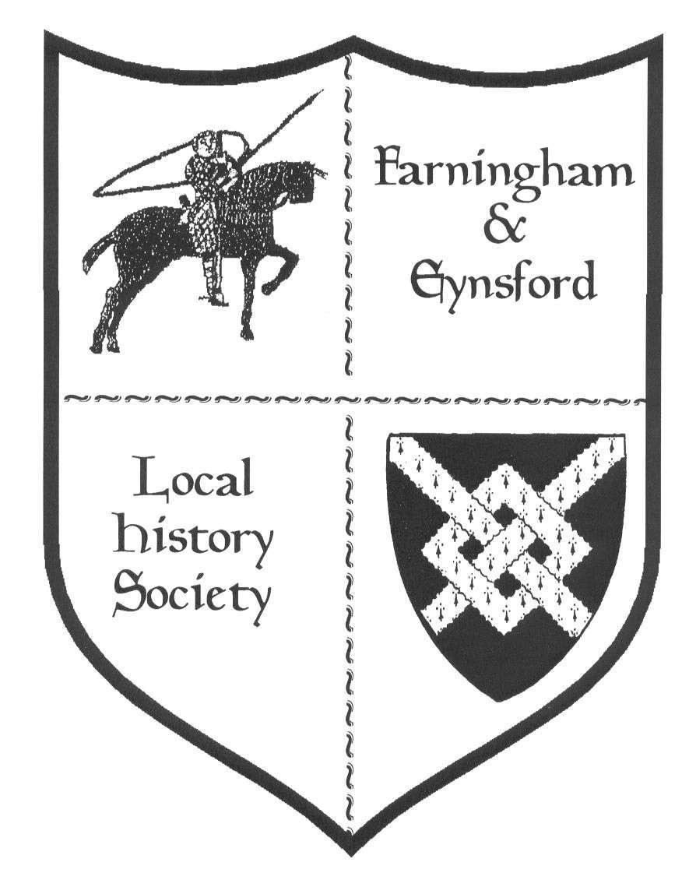
Farningham & Eynsford Local History Society established 1985. Registered Charity No. 1047562)

Bulletin No 73
March 2007

Annual General Meeting
The AGM will take place at Eynsford Village Hall on Friday 11th May at 8pm (doors open 7.30pm)
The Agenda is as follows:-
1. Welcome 5. Setting of the Subscription level for 2008
2. Apologies for absence 6. Election of officers and committee
3. Minutes of last AGM and matters arising 7. Any other business
4. Adoption of audited accounts for 2006
Nominations for officers or committee members should reach Secretary by 1st May 2007
Forthcoming Talks and Events
2007 Details Where
13th April Mysteries and Cover-ups - Andy Thomas Eynsford
(Tickets £10 including two course supper)
(Doors open 7pm)
11th May AGM (Buffet and music supplied by Darent Eynsford
Valley Youth Orchestra)
6th July ‘1066 and all that, Part 3’ Quiz Night with Alan Cremer Eynsford
(Tickets £3 each, in tables of 6. Please bring your own
refreshments) (Doors open 7pm)
28th Sept Pipe Dreams - Phil Cole and Brian Boyden Farningham
(a talk about clay pipes in English Society)
16th Nov A Kent Christmas (details will follow at a later date) Eynsford
Unless otherwise stated all Meetings are held on a Friday evening from 730pm, talk commencing 8pm. (Note: front row seats can be reserved for members with hearing or eyesight difficulties and hearing loops are now available on request)

REPORTS FROM COMMITTEE

CHAIRMAN’S REPORT (Barbara Cannell)
So begins another year, I wonder what the Society will achieve in the next twelve months. I do know that my diary is fast filling up with events not to be missed and places where it would be nice if the Society were present. With all the things we do we are always pleased if you want to come and help, please let us know, after all many hands make light work!. Likewise if you hear of a display, exhibition or any other event where you think the Society might be interested in attending, where we would be able to sell our publications or copies of our postcards and photographs or even arrange a small display of artefacts then please give us the details.

PUBLICATION REPORT (Barbara Cannell)
Wilf Duncombe has finalised a publication on Elliott Downs Till, a review written by Jan is printed below. Many of us have grown up with stories about Mr Till, but for residents new to the village of Eynsford this book should surely be a ‘must have’ guide to some of the historic buildings in Eynsford and life at the beginning of the last century.

Don’t forget to look on the publications table at evening meetings - you might find some surprises.

Elliott Down Till 1835 - 1917 Friend & Benefactor of Eynsford by W G Duncombe (£3.00)
This is a beautifully written publication with some stunning photographs which gives an
insight into the life of E D Till. After reading this you will be inspired to go out and
have a good look around Eynsford and see things you have never seen before. First step is the village hall and seek out the painting of Elliott Downs Till, next purchase the publication, next read and enjoy. Lastly ponder on what life in Eynsford
may have been like if Mr Till had decided not to spend his retirement here.

SECRETARY’S REPORT ( Elaine Ruby )
If you haven’t done so, now is the time to get your tickets for the Mysteries and Cover-ups evening with Andy Thomas. Andy gave us a talk last October on Crop Circles and his latest talk will prove to be just as interesting and thought provoking. The tickets are £10 and include a two course supper, Beef goulash (there will be a vegetarian option for the non-meat eaters) followed by Tarte-aux-pommes and cream. We will also run a wine bar. We can only cater for 80 people so reserve your tickets now by calling Jan 865122.

We also hope we will get a good attendance at our AGM on Friday 11th May from 730pm at Eynsford Village Hall. Following the conclusion of the Society’s business we will be pleased to welcome the Darent Valley Youth Orchestra who will play for us while we all enjoy the buffet supper and a glass of wine.

RESEARCH REPORT (Susan Pittman) (website www.felhs.org.uk)
Reissue of OS ‘Old Series’ inch-to-the-mile maps first published 1805-1874

For the first time these famous maps are available in a format that exactly matches the coverage, scale and sheet numbering of the modern 1:50,000 OS Landranger© series. Digital enhancements have improved clarity. Cost £6.49 + postage and packing, via Cassini Publishing, Hillsprings, East Garston, Berkshire RG17 7HW.

www.visionofbritain.org.uk
This website aims to show how Britain’s towns, cities and landscapes have changed over the last 200 years. Simply enter a postcode or place-name into the site’s search engine and all that is known about a particular area comes up. Among the statistics available are population, employment, housing, education, religion, birth and death registers with OS maps and Land Utilisation maps of the 1930s.

Memories of Eynsford/Farningham from Mrs Pat Annett nee Bryant
(via letter to Gloria Gee)
Pat’s grandparents, Arthur and Annie Bryant, used to live at 1, Elizabeth Cottages, Eynsford, and Pat has many happy memories of staying there.
She visited the Village Hall for concerts on many occasions - her grandma used to be in the sketches and she well remembered her being on stage in her white apron making pastry in some sketch or other. Her aunt Gertie also used to play the piano on stage and she remembers her playing ‘The Teddy Bears Picnic’ with the local Cub group. Her aunt Barbara played the organ at St. Martin’s and many a time Pat was detailed to pump the organ (and Pat letting her aunt down when her attention wandered!) She remembered Gee’s Stores and playing with Peter Gee in the stream under the bridge. Pat was actually living at South Hall in Farningham with her aunt and uncle Woolley at the time and went to school there. Mr Hetherington, whom the children always called ‘Gaffer’, was the headmaster.
Pat wonders whether any of the original children are still in Farningham and remember her. She recalls sitting next to a lovely boy whose face she can still see, but not his name. She reckons she learnt more at that school than any of her later secondary education. It was truly wonderful! (can anyone help with a date for this?)

1771 will of Susanna, wife of Thomas Fuller of Lullingstone
She gave her four brothers, William, James, Edward and Anthony Aynscombe and her sister Rebekah, wife of Andrew Bath, £20 each. The rest she left to Susannah
Hunt, the natural daughter of her brother Edward to bring her up to the age of 24 or the day of her marriage, whichever was sooner.

Ancient by-laws of Sevenoaks from 1612 belonging to John Bankyn, maltman of Eynsford
1. No cattle to go by the street without a keeper
2. No hogs not justified*
*(i.e. without nose ring - the amount of damage a pig can do by rooting about, even on a cobble street needs to be seen to be appreciated (Gordon Ward, Sevenoaks Essays)
Theft of cloth at Farningham, 1573
John Thatcher, labourer of Farningham, and William Chapman, a cobbler from Holborn in London, were indicted at the Kent Assizes for breaking into the close of Thomas Foster in Farningham on 18 September 1573 and stealing thirty yards of turkey-coloured broadcloth, worth £12, belonging in John Coucheman. Chapman was found guilty, but Thatcher had escaped from Maidstone gaol and was at large. A later Assize entry records that James Busbetche of Maidstone, yeoman and keeper of the gaol, was indicted for negligently allowing the escape of John Thatcher. Thatcher was committed to the gaol on 21 September by Thomas Lovelace J.P., but escaped on 28 September. Foster was imprisoned, but what happened to the other two is unknown.

Some references to the C16th Hart family of Lullingstone in ‘A Memory of Honour, the life of William Brooke, Lord Cobham’ by David McKeen
William Brooke inherited the Cobham estate from his father in 1558. When he took over Cobham Hall his family was made up of entirely young people - he at 31 was the oldest and a widower. His uncles by blood were dead, but he had several aunts including Elizabeth Hart of Lullingstone third wife and widow of the overseer of his father’s will. William Brooke went on to become father-in-law of Queen Elizabeth’s chancellor, Lord Burghley, and rose under his powerful wing. When William Brooke died in 1597 there was a great funeral at Cobham at which, “relegated to less conspicuous position was another relation, Percival Hart, the widower of Cobham’s only child by his first marriage.”

1322 description of Eynsford in Inquisition Post Mortem of William Inge
This inquisition was held at Eynsford. Those who testified to William’s estate on oath said that he held the chief messuage of the moiety of the manor of Eynsford worth 40 old pence a year. There was a dove-cote worth 40 old pence a year, 80 acres of arable land worth 4 old pence an acre a year; 7 acres of meadow worth 18 old pence an acre a year; 40 acres of pasture worth 2 old pence an acre a year. There was also a watermill worth 20 shillings and various rents and perquisites which brought the value of his part of Eynsford to £10-10s-6d.

Family history enquiries
Blagden/Beanham - of Crockenhill and Eynsford
Cheeseman - of Shoreham. Alice Cheeseman worked in the ammunitions factory at Lullingstone in the First World War making pins for shells.
Farrer - G. H. Farrer was publican of the Plough in 1938.
Fellow/Floyd - of Eynsford, and their Baptist connections.
Mace - of Crockenhill, publican of the Chequers in the 1900s.
Rogers/Devine - of Crockenhill, traction engine drivers.
Smith - of Crockenhill and Shoreham.

ARCHIVE REPORT (Susan Pittman)
The electricity has now been reconnected, and the inside electrical fittings are near completion. Unfortunately, the lack of background heating over winter has led to some damp on one window sill, but this should be easily rectified. In the next few weeks the furniture is due to be taken out of storage and most of it will be placed in the centre. Some unsuitable items which we have held in case they were needed will be disposed of, but most will be used until better equipment can be afforded or grant aided. The process of transferring the collection will be slow, partly because of the time constraints of your committee members, partly because we want to be sure that the items are fully catalogued and checked before going on the shelves. We also need to have a system of storage which enables us efficiently to locate individual items. As an extra precaution we plan not to place any water damageable items near the floor, in case there should be an unusually high flood, although as far as we know the centre has heretofore been above flood level. We hope members will be patient with our approach because setting up the centre properly at the beginning will be of great benefit in the long run.

Acquisitions
1 3 photographs of The Castle Stores, Eynsford, in mid 1950s/1964 from Sybil Sheppherd via Ed Holbrooke.
2 Message of thanks, 8 June 1946, to school children from George VI; “you have shared in the hardships and dangers of a total war and you have shared no less in the triumph of the Allied Nations” from Sally Heddle.

Can anyone assist with the following? :-

Farningham Cricket Club is 150 years old this year. The 100 year history was marked with a publication by Bernard Drew entitled “A Hundred Years of Farningham Cricket”. This is a 28 page booklet of highlights over the century. The club would love to extend this to include the next 50 years. We are looking for someone who has the expertise and would be interested in undertaking this project.
Also if there is anyone who still lives locally with any stories to tell from the last 50 years I would be pleased to hear from them.

If you are interested in any way with helping with this project please contact Darren Blake, by phone on 07914 374161 or e-mail darren9169@yahoo.co.uk or farninghamcc@googlemail.co.uk

BULLETINS BY E-MAIL (Stella Baggaley- Membership Secretary)
If you have an e-mail address and would like to have your bulletin sent electronically. Let me know by sending an e-mail to stelbag@aol.com

and finally (Editor Jan Wilkes - 865122)
As I mentioned in the last Bulletin I have now changed the format a little, couldn’t change it in a big way because the finer points of computers are a mystery to me. This statement got me thinking, pre computers in the 1970s I used to use an IBM Executive Typewriter and I used to produce letters, proposals, graphs, booklets, publications, programmes you name it I did it on that typewriter, not to mention making templates and running off hundreds of publications on a Gestetner, so computers should be a walk in the park.......But if asked if I would like to go back to those days, the answer is no and to
be honest I don’t know how on earth I did it. The past is a bit like that, a wonderful thing to learn about, but not a place where we would necessarily want to be.

WHAT’S ON 2007
Horton Kirby & South Darenth Local History Society

14th May Dirty Dartford - Chris Bull
9th July The History of Papermaking in the Darent Valley - Jean Stirk
10th Sept Blondes, Bullets & Fast Cars - Ron Walford
12th Nov ‘The Suburb that Never Was’ Lullingstone - James Connor
All meetings are held in the Village Hall, South Darenth from 8pm. If you require further information contact Keith Sanderson (Remember your membership card)

Shoreham & District Historical Society

16th March AGM and Shoreham Houses a talk by Ken Wilson
Meetings held in the Village Hall Shoreham from 8pm. Members who wish to attend these meetings are advised to contact the Secretary. Ed James to check that no changes have been made to their programmes (Remember your membership card)

Hextable Heritage Society

22nd March Dartford through Time - Chris Baker (Dartford Museum)
26th April Hartley Church - Gerald Cramp
24th May AGM plus local pictures with John Meakins
28th June Cinemas - Andy Garner
26th July 19th Century Kent - Bob Ogley
All meetings are held at the Hextable Heritage Centre off College Road. 7.15pm for 7.30pm start. If you require further information please contact Barbara Cannell

KAS Historic Building Committee

7th April Meet 1030 am Shorham Village car park.(Morning) A conducted tour of the village looking at the historic buildings followed by a discussion in the church. Lunch at the village hall (£5) (Afternoon) A Guided tour of Eynsford (further details available from Joy Saynor 01959 522717 or e-mail saynor@shorehamkent.wanadoo.co.uk

Council of Kent Archaeology

14th April A conference examining the major discoveries, historical and oral traditions, landscapes and buildings of the upper Darent Valley.
Sevenoaks Community Centre, Otford Road, Sevenoaks 2pm to 5.30pm
(Details can be found on www.the-cka.fsnet.co.uk or from Ruth Plummer
on 0208 777 7872 e-mail davru58-arch@yahoo.co.uk

