Farningham & Eynsford Local History Society
(Original Society founded 1985 Registered Charity no 1047562)
A Charitable Company Limited by Guarantee
No. 5620267 incorporated 11th November 2005 Registered Charity 1113765
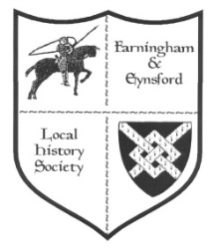

Bulletin No. 125
Winter 2020/2021

2020 AGM FELHS ANNUAL GENERAL MEETING REPORT
I would like to thank all those who took part in the Annual General Meeting held on 21 August, whether by e-mail or post. Sixteen members responded, which we are told is relatively good for societies holding a virtual meeting, and gave a quorum. All were unanimous in approving the reports, membership subscription and re-electing the committee. There were no spoiled papers and, importantly, no evidence of fraud in the postal votes!
John Mullen, Secretary

MEMBERSHIP SECRETARY (Alison Marshall 01322 862298)
We would like to thank all members for their loyal support, and urge you to continue your membership. Although our meetings have been disrupted and we have missed the pleasure
of sharing our interest in the history of our villages at them, FELHS still reaches out to you with the Bulletins, which are fuller than those of many Local History Societies. It also runs The Centre, a treasure-house of local information, images and artefacts. Such collections take years, decades even, to build up. The Centre is the envy of several villages, and its collections provide an on-going resource. The Centre incurs running costs which obviously need to be paid, even though it has had to be closed to visitors.
- With this issue of the Bulletin comes the reminder to annual members to renew subscriptions. You will find a renewal form attached or enclosed, depending on your preference.
- When you complete the form please do sign the Gift Aid section if you are a tax payer because it helps the Society by making your subscription more valuable.
- Please return completed forms to Alison Marshall by e-mail (alisondukes@btinternet.com), post or by putting them through the door at 11a Riverside, Eynsford, Kent DA4 0AE - it is on the track to the Cricket Meadow.
- You can now find bank account details on the form if you prefer to pay by bank transfer (letting Alison know). Otherwise please include your cheque or cash in the envelope with your form.

NEW - FELHS now on FACEBOOK @felhs.1985
From Vikki and Helen:
We have just set up a Facebook Page @felhs.1985. As we have had to postpone or cancel our events and talks this year due to COVID-19 we still wanted to share with everyone items that are in our archive and other matters that relate to the local history of the area. In the coming weeks and months we hope to post photos and articles that will be of interest to our followers whilst we can't meet up in person. Do search us out and give us a Like. If you have any suggestions of items that you would like to see on the page please email us at info@felhs.org.uk

2020 - TALKS AND EVENTS
We have reluctantly decided to abandon the rest of the 2020 Programme, although we hope that the speakers will agree to re-schedule.
2021 - PROGRAMME
Adjustments have had to be made for the early 2021 programme & others might have to be made according to restrictions in place at the time
12 February 8.00 p.m. Likely to be held on Zoom
Graffiti in Eynsford, Farningham & Lullingstone Churches - Wayne Perkins has studied these and will reveal a fascinating aspect overlooked by most when they visit churches.

12 March
Mystery Artefacts Quiz - cancelled because this involved handling objects.

16 April Farningham Village Hall To be kept under review
Firefighting in Kent: A general overview of firefighting throughout the ages.

7 May (AGM) Eynsford Village Hall
We are going to try to hold the AGM, but it may have to be a low key meeting at social distancing.
The Programme for the rest of the year ..... subject to restriction allowing
17 September Eynsford Village Hall
Lady Zoe Hart Dyke and the Lullingstone Silk Farm
Claire Weiss has written a fascinating book on this subject.
15 October Farningham Village Hall
Local brickfields and brick making
David Cufley will cover two brickfield sites in Eynsford, Stevens' brickfield in Crockenhill and other local sites.
19 November Eynsford Village Hall
Rural Rides in the Delightful Darent Valley
Christoph Bull will reveal beautiful places and astonishing people of the lower Darent Valley.

COMMITTEE NEWS
The Committee managed to have two meetings outdoors and one held by e-mail exchanges. Most of us are now on Zoom, and it is hoped all will be by the next Committee meeting, so we will be able to see each other and hold discussions during the winter months.
The FELHS Facebook page has been set up (see box above).
Eynsford and Farningham Village Halls have sent round detailed Covid-19 policies for their users. The codes will keep everyone as safe as possible, but require more supervision than FELHS Committee thinks it can implement. We would therefore appreciate volunteers at the beginning and end of meetings to ensure the strict hygiene regulations are met. Please get in touch if you would like to help. We would also need to know attendance would be reasonable.
The speaker in February would like to try to give his talk on Zoom, which might be a way forward for those with the facility. If you are not on Zoom and don't know how to download it, try to get someone to help you. It requires a device with a camera. If you are on Zoom and think talks via this method might be of interest, perhaps you could register an interest with a Committee member, using any contact details given in this Bulletin.
We still need a new Meetings Secretary. The 2021 Programme has been arranged, although how much of it will be achieved is uncertain. With several talks postponed we have a list of speakers ready to slot into a 2022 programme, so the task will not be onerous, and we would welcome a new Committee member.

IRENE WHITTAKER M.B.E. 18/10/1918 - 05/08/2020
Irene was one of the founder members of FELHS and very much enjoyed the meetings and exhibitions even in her hundredth year.
She was a much respected Head of a new primary school in Gravesend where she developed a child centred approach to teaching, and was invited to serve on a number of government bodies and advisory groups. As a musician, she played the violin for the Goldsmith Orchestra. She will be sadly missed by many groups in the villages and very much so by her friends and family. She spent her last few weeks in Emerson Grange, Hextable.
Veronica Sheppard, Chairman

FARNINGHAM & EYNSFORD LOCAL HISTORY CENTRE
WITH LIMITED ACCESS
(Unless Government restrictions become more stringent)
On application individual researchers could be given access, following social distancing and with masks and gloves, but permission would be dependent on what searches need to be made. Otherwise ...
ENQUIRIES CAN STILL BE MADE & ANSWERED
Enquiries via archives@felhs.org.uk website: www.felhs.org.uk Facebook: @felhs.1985

RESEARCH REPORT
Susan Pittman, 01322 669923, archives@felhs.org.uk

FELHS website updated and new page added
The '5 Communities' section accessed from the Home page gives brief outline histories of Eynsford, Farningham, Crockenhill, Lullingstone and Maplescombe. This section has been updated to take account of changes since they were written.
Under 'Research and Queries', also accessed from the Home page, now appears a list of the 52 subject folders in the filing cabinets, and their sub-sections. This should help all those interested to find out the range of material available, and also to see whether a broad topic is covered. Do have a look you might be surprised what is found there.

New publications a possibility
FELHS was contacted by a publisher looking for new titles, some of which are being pursued, but it is too early to raise expectations. New research is needed, and time spent on collating material, so delivery is some way off.

Family papers at Lullingstone Castle catalogued
At Sarah Hart Dyke's invitation I spent seven hard-working days in August sorting through a mass of material putting it into some sort of order and cataloguing it. I have sent a copy of the list to Kent History and Library Centre at Maidstone for reference. Most of the collection dates to Sir Oliver Hart Dyke's residency from the 1950s into the 1970s. During this time there was gravel extraction south of the Castle, the restoration of the gatehouse following its damage in the Second World War, and various alterations, modifications and conversions to the Castle to modernise it and to form separate dwellings within the Castle and its outbuildings. From earlier in the C20th the collection comprises researches into family history, particularly undertaken by Sydney Hart Dyke. There was a case full of albums and newspaper cuttings of Mary Bell (Dyke) as maid-of-honour to Queen Alexandra. There were several photograph and newspaper cutting albums, of general interest rather than about the family directly. There are only three items from before 1800, including the inventory of Sir Percyvall Hart of 1687 (see below).
NEW BOOK ABOUT CROCKENHILL FOR CHRISTMAS
JOHN WOOD & FAMILY
FARMERS OF THE MOUNT, CROCKENHILL, KENT
Susan Pittman Ph.D.
This is the third in a series of five. All are richly illustrated with old and new photographs. The families are used within context to tell the wider history of Crockenhill and its surround.
Already available via Crockenhill Parish Council Office (Stones Cross Road, Crockenhill BR8 8LT - 01322 614674):
- The Miller Family - Farmers at Wested Farm (once U.K.'s largest peppermint grower) (60 pages, £8 + postage)
- The Lee Family - Farmers at Crockenhill (early advocates of cold storage of fruit
(132 pages, £12 + postage)
To follow - The Clements of Gosenhill; Background to Farming in Crockenhill.
NOW (If not delayed by Lock-down - contact archives@felhs.org.uk to check)
John Wood & Family:Farmers of The Mount, Crockenhill
(248 pages, £15 + £4 postage)
The story of a leading fruit grower in the U.K., also reveals much of Crockenhill's history, and indeed the history of the area.
- John Wood in the forefront of growing strawberries and promoter of the use of dwarf rootstock for orchard trees.
- The scale of the industry led to the development of Crockenhill - housing and shops for the workforce, 1890-1910.
- The protest movement of Crockenhill farmers over paying tithes to the Church.
- The 2-month farm labourers' strike for better conditions in 1914.
- Links with the non-stop distance flight record attempt to India in 1927.
- The first V2 to fall in Kent and 4th to fall in this country.
- Crockenhill Village Hall built

Archeological digs near Lullingstone
Archaeological digs have been going on in the valley under Dr Anne Sassin from the Darent Valley Landscape Partnership Scheme. The field behind the Roman Villa has revealed a possible enclosure ditch of the Villa and a ritual shaft cut into the chalk. Anne offered to give a talk in the future when the finds have been assessed. After the 2019 dig near the Roman Villa some pieces of millstones were sent to a specialist. She found that they had been imported from Derbyshire and Yorkshire for use as millstones, but their use in rotary hand operated querns was not ruled out. It is possible there was a watermill at Lullingstone, but the fragments found to date were too small to take measurable dimensions.

Eynsford Electorate in 1734
In the poll for Knights of the Shire elections there were 14 freeholders eligible to vote in Eynsford of which six are recognisable Crockenhill names. The list includes Beckett (2), Pryor, Cox, Haywood, Hazell, Fisher, Mosier (2), Gorden (Farningham), Donmoll, Simmonds, Durling, Dalton.

Death of Sidney W. Gibson, 1933
The obituary stated that he had been an agricultural engineer in partnership with his father for 48 years. In 1886 they opened Eynsford Iron Works and later took over an ironmonger's business in Dartford. From 1894 to 1920 Sidney was surveyor to the Darenth Valley Main Sewerage Board, and after 1920 its engineer. He was a Baptist and played an important part in the project to build the present Chapel in 1906.
Incidentally, one of the documents at Lullingstone Castle is an engineering drawing initialled SG 1904 of the generator and pump for the pump house, which linked with the reservoir for the Lullingstone estate water supply. It made me wonder when the private water supply was set up.

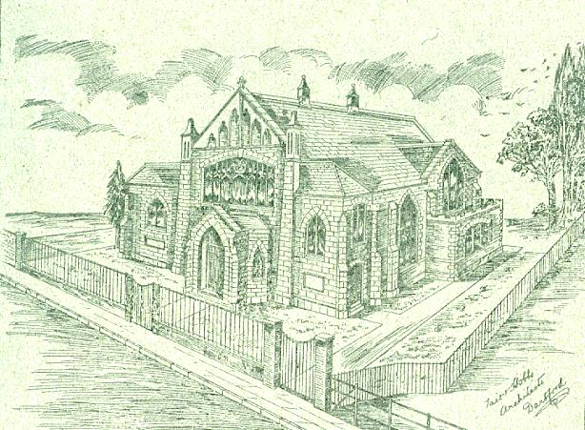

Tait & Hobbs Architect's drawing for the new Baptist Chapel at Eynsford c.1906.

(Chronicle & Courier 7/4/1933: see also Wilf Duncombe's FELHS publication Gibson Family of Eynsford & Farningham Blacksmiths and Ironmongers)

Venison from Lullingstone Park - letter from 191-
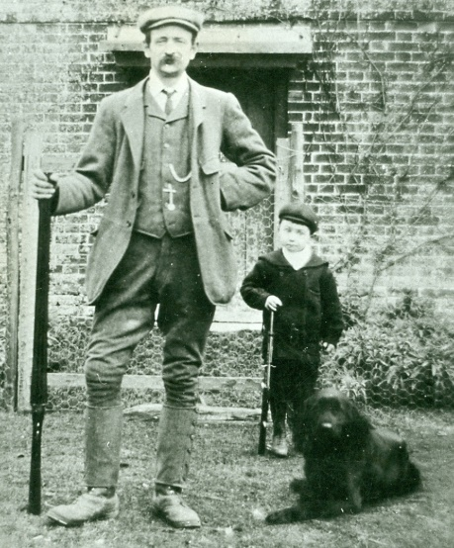
A letter sent from J. Bridgman, a poultry, game and venison dealer from West End Poultry Market to George Reeves, deer keeper at Lullingstone Park: I am pleased to report an extraordinary demand for FRESH KILLED FAT DOE VENISON - of course, these must be dressed at all times in exactly the same way as sheep are dressed. It is many years since we have had such a big demand after Xmas, and should you be reducing your herd any more this season I shall be glad to receive them. I can assure you that you will be quite satisfied with my returns.

George Reeves, gamekeeper from 1902-1940, and his son, John (born 1903), outside Well House, their home in Lullingstone Park, which lay along the present 17th fairway of the golf course, 1913.

Pax, Priory Lane
Mention was made in an earlier Bulletin of Elliott Downs Till's experimental house for working families which he called 'Pax'. Jean has sent in a photograph of 'Pax' and more information about the house. Her paternal grandfather (Edwards) was living in 'Pax' on his marriage in 1909. Its access was at the rear up the left fork of Priory Lane beyond the end of Till's house 'The Priory'. In 1911 as Pax Bungalow it is described as a gardener's lodge with Mr Spickett in residence.
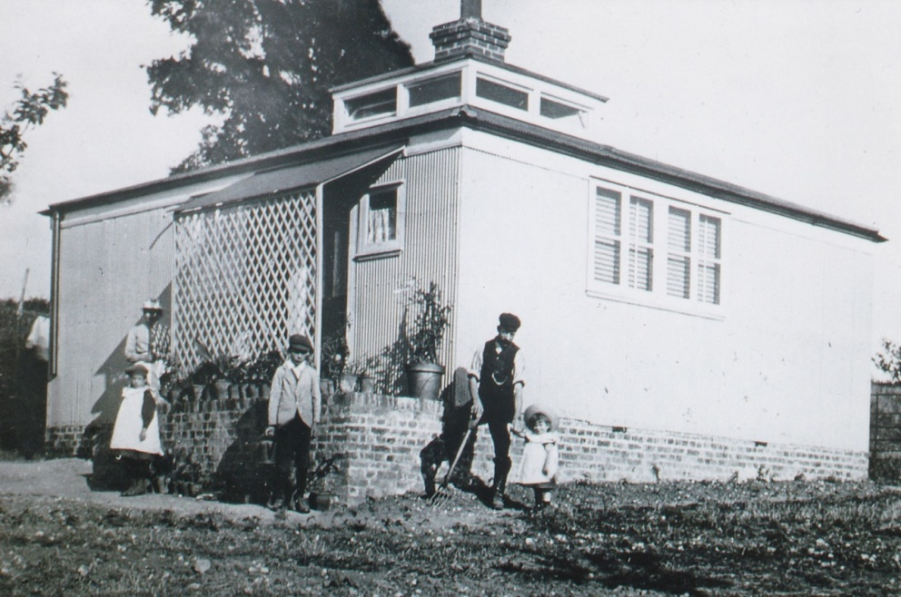

'Pax' perhaps c.1909 when the Edwards family lived there.

The Nash Mausoleum, Farningham Churchyard
One update made to FELHS website and to the Farningham walk concerns the Nash family. It has been widely written and assumed that this family was related to the famous Regency and Georgian architect John Nash (1752 –1835), who, among other buildings, was responsible for the design of Marble Arch and ‎Buckingham Palace. The late Geoffrey Copus drew up a family tree for the Farningham family, taking it back to 1762, and no link was found. The architect's family was largely Welsh, while the Farningham family was deeply rooted in the village. The mausoleum was erected after the death of Thomas Nash, a calico printer, in 1778. His brother, Dr John Nash, also buried in the mausoleum, was a medical practitioner in Sevenoaks. In Farningham Church there is a brass memorial plaque in memory of the architect Edwin Nash (1814-1884). He was the great-grandson of Thomas and John's brother, William, and the architect who designed Crockenhill All Souls' Church in 1850.

In loving memory/ of/ Edwin Nash, F.R.I.B.A./ of Sydenham, Kent./ Died 14th May 1884, aged 71/ and of Euphemia, his wife,/ died 5th Sept. 1905, aged 83.

Sir Percyval Hart's Inventory, 1687
Nineteen rooms were listed, but included outbuildings, so either the house was smaller or some rooms had nothing in them?! The main rooms were the dining room, the kitchen chamber, the new room, the long gallery, the maids chamber, the with-drawing room, the red chamber, the chamber next to the dining room, the hall, the kitchen, the wet larder, the dairy room, the men's chambers, the cellars - outside were the brew-house, the stable, the stable yard, the coach house, and the corn barn. The items outside the house seem to have been more valuable than those inside. The bed, furniture, pictures and satin hangings valued at £9 made the contents of the red room the most valuable, but outside two coaches were worth £40 and farm equipment £80. Sir Percyval had a chamber in The Temple with two feather beds, a couch and a study of books worth £30. Altogether the appraisers totted up £1553 4s 6d, which in today's money would be about £374,584.

General Enquiries
Farningham Parish Council website - We were asked to check and update the walk round Farningham.
Stone plaques on Farningham bridge - Farningham Parish Council was interested in their better conservation. I referred them to Kent County Council Highways bridge specialist and to Kent Historic Buildings Committee.
Farningham Church - Information was requested for updating visitor paddles in the Church.
Pumping station at Swanley - Helen's lock-down walks took her past this brick pumping house next to a reservoir and she was curious to know its age. I looked up a few maps and found it did not appear in the 1907 OS map, and speculated that it might have been connected with glasshouse cultivation which was so prevalent in this area.
Vulcanised Fibre & Spalding Russell - Enquirer about this Company was referred to Wilf Duncombe's FELHS publication Eynsford Paper Mill.
Lullingstone House, Canterbury - Richard wanted to know the link with Lullingstone, but I could find none. However, I did advise on how he could research the house history to reveal when the name was first used and by whom, which could unearth a link.

Family History
Audrey Gee - Onno from the Netherlands was seeking an Audrey Gee, but it was not our one. Onno has adopted the Second World War grave of Private William Charles Gee, but further research revealed that his daughter, Audrey Gee, was born in Lancashire.
Roper - Dee's mother believed she was descended from Sir Thomas More, and Dee wanted to learn more about Roper's Charity. I referred her to FELHS publication no.9 The Charities of Farningham and Eynsford with Crockenhill and Lullingstone by Hilary and Wilfrid Harding.
Crockenhill queries reported here, but papers to be deposited in Crockenhill Heritage Room:
Mace - Having helped Janet over land tenanted by Thomas Mace in Crockenhill c.1789, she asked advice about how to progress her research. I sent a list of wills to follow up, and linked her to other Mace enquirers including Steve mentioned in the last Bulletin.
Perrett - Pat sent a wedding photo (1949) of Charles Perrett (died 1984, buried in Crockenhill Baptist cemetery) and Freda Collins (b.1927) who lived in Eynsford Road, Crockenhill – both worked at Nash Paper Mills in St Paul's Cray.
Reeves - James was researching his late wife's family and found that her uncle, John Reeves, was born in Lullingstone. I have a file on the family because John's father, George, was gamekeeper in Lullingstone Park. John's sister, Mildred, let me copy several photos of her father in the Park, including one of John, so I was able to send James a copy, and in return he sent some family Reeves' documents. (See item above)
Steadman - Brian comes from the Steadman branch of the Lee family of Crockenhill, and wanted to know the site of Steadman's baker's shop and James Lee's house, which I was able to provide.
Wood, Whitehead, Packman, Hiseman - Under lock-down Louise has begun delving into her family history with vigour and has kept me busy with queries. These families are widespread in our area, but especially in Crockenhill.

ARCHIVE REPORT
Susan Pittman - 01322 669923, www.felhs.org.uk
We have not been able to return as a group to the Centre, but do visit occasionally to check the building and to do research to answer queries. We have been asked by insurers to formulate a Health and Safety Policy, which has been done, and a Covid-19 policy by the Charity Commission, which has been done for the Centre, but not completed for the Village Hall venues. Village Halls have their own policies, but FELHS is required to formulate one to cover its own particular circumstances.

Acquisitions
Stella Baggaley - A marvellous run of Farningham Church Magazines from 1894-1974.
Diana Beamish - Print out from Find My Past - Famous family trees: Miranda Hart. Miranda descends from the 5th baronet, Sir Percival Hart, as does Sarah Hart Dyke, who is her aunt - hence the relevance to FELHS collection. The print-out contains copies of several census pages including one of 1841 showing twelve Hart Dykes from 3 generations at Lullingstone Castle with 21 servants; print out 1734 Eynsford poll for Kent knights of the shire.
Wilf Duncombe - Charts of minimum/maximum temperatures taken at 19 Pollyhaugh 2014-2019. In 2014, 2018, 2019 maximum temperatures reached over 90ﹾ F, and the minimum reached below 20ﹾF in 2018; DVD 2019 revised Gibson publication; Kent Archaeological Review 2001 article about burial at Pollyhaugh. Wilf has added a note that the address of 10 Pollyhaugh given was the plot number, now the location of properties 16 or 18; photocopy excerpts from old printed sources & handwritten notes; copy of Farningham bound book entitled Registers of Christenings, which contains notes on the tithe dispute between the Vicar of Farningham and the Dean and Chapter of Canterbury; 1866 plan of Bay Tree Cottages and adjoining plots, Eynsford.
Jan Wilkes - Has passed on several photographs including some from the 1970s of Anthony Roper School staff & events from Margaret Newbold (Mrs Barker when she taught at the School).
One of two stone tablets on Farningham bridge:
This Bridge/ was rebuilt by order/ of the Court of/ Quarter Sessions 1774/ Edward Gray Architect
The second tablet reads:
Repaired/ by the County and/ widened 8 feet by/ subscription 1833/ (lower line unreadable on photograph - probably name of contractor - perhaps someone could have a go at deciphering it on the spot and let me know the result!)

