Farningham & Eynsford Local History Society
(Original Society founded 1985 Registered Charity no 1047562)
A Charitable Company Limited by Guarantee
No. 5620267 incorporated 11th November 2005 Registered Charity 1113765
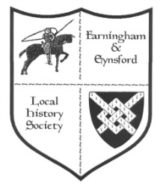

Bulletin No. 124
Summer 2020

2020 AGM FELHS ANNUAL GENERAL MEETING
The Chairman's report incorporating other reports, and the accounts with the Treasurer's report, have previously been circulated by e-mail. Postal members will receive their copies with this Bulletin, and other members will have another copy attached. This is because the Directors and Committee have decided to adopt a digital/ postal voting system, rather than wait for a time in 2021 when we can meet in person. All the information about the proposed arrangements come at the same time as this Bulletin. Please do participate.

2020 - FORTHCOMING TALKS AND EVENTS
We have reluctantly decided to abandon the rest of the 2020 Programme, although we hope that the speakers will agree to re-schedule.
The 2021 programme has been finalised, and can be found on the website.

FARNINGHAM & EYNSFORD LOCAL HISTORY CENTRE
CLOSED UNTIL FURTHER NOTICE
ENQUIRIES CAN STILL BE MADE & ANSWERED
Enquiries via archives@felhs.org.uk website: www.felhs.org.uk

EXPERIENCING LIFE WITH CORONAVIRUS - COVID-19
We are living through abnormal times, with the threat and fear of the pandemic which has descended upon the world. Your personal memories recorded now would be of great interest to future generations - How has your life changed? How have you adapted and coped (or not)? If you have taken photos or have kept ephemera, such as leaflets, notices, adverts, please do not throw them away, but save them for FELHS. It would be invaluable to have a record of how Eynsford, Farningham, Crockenhill, Lullingstone and Maplescombe residents lived through this period. Please see what you can do for this.

COMMITTEE NEWS
We are working on setting up a FELHS Facebook presence, and hope to have details in the next Bulletin.
We still need a new Meetings Secretary. At present we are sharing the task, but it is not an ideal situation because it overstretches other committee members. As the 2021 Programme has been arranged there is time for any new volunteer to bed in.

RESEARCH REPORT
Susan Pittman, 01322 669923, archives@felhs.org.uk

Copies of Trident: June - December 2019 wanted for the Centre
We used to be given copies regularly, but the donation has stopped. We have a complete run of Trident until June 2019, so if you have July, September, October 2019 please think of us. Phone and we can arrange collection or drop off.

Filming in Farningham
'Flesh and Blood' was shown on ITV on four consecutive nights from 24 February 2020. Some of it was filmed in the village of Farningham. The Kent Film Office helped to find the locations for the film and it estimated that the three days filming contributed £18,000 to the Kent economy.

Kent Country Churches Concluded by James Antony Syms (Meresborough Books, 1989)
I was given this book recently and found that it included Eynsford, Farningham and Lullingstone Churches with delightful sketches by the author.
- St. Martin's, Eynsford - 'As far as my knowledge extends, one of only two country churches in Kent with an apse which here is genuinely medieval whereas the other, Sutton (near Dover) is a Victorian reconstruction.'
- St. Peter & St. Paul's, Farningham - 'There are medieval churches by the hundred in Kent but mausolea of the Nash quality would not exhaust the fingers of one hand.'
- St. Botolph's, Lullingstone - 'Beyond the screen, in the chancel and chapel, one enters the domain of the Hart Dykes and their predecessors, everywhere restricted except for the monuments which are life size and flamboyant.'
Farningham Church from book by Dunkin, 1800 - note the church was then thatched

The Thames Embankment and local Coal Posts
In the 1850s there were heated debates about the route required for the provision of a modern sewerage system for London. Engineer Joseph Bazalgette suggested that a low level sewer should run under the route of The Strand, but this was considered to be too disruptive, so in the 1860s embanking the Thames was being advocated. This would improve the unsightly river banks, give a new road to improve traffic flow, while at the same time allowing the construction of the sewer. The Metropolitan Board of Works established in 1855 built three embankments having considered more than fifty designs for a northern and a southern embankment:
- The Victoria embankment (Westminster Bridge to Blackfriars Bridge) 1864-1870
- The Albert embankment (Vauxhall to Westminster Bridge) 1866-1869
- The Chelsea embankment (Chelsea Hospital to Battersea Bridge) 1871-1874
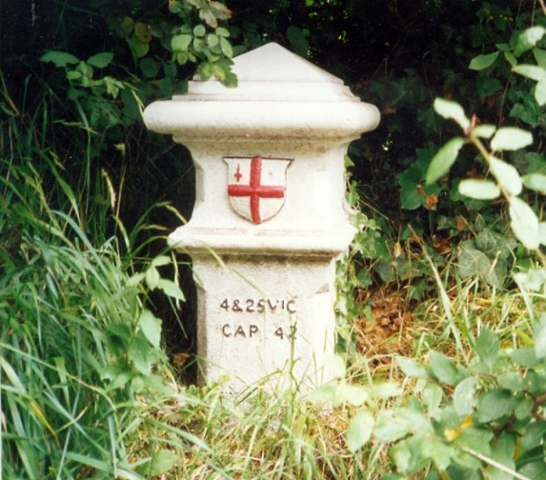
To raise money the 1861 Coal and Wine Duties Act was passed. The coal posts defined the boundary of the duty area and coal merchants inside the area had to pay four pence on a ton of coal. Suppliers of coal had to submit returns so that inspectors could check on payments. The duty continued to be collected until 1889. As well as the Thames embankments the duty helped pay for Holborn viaduct, end tolls over seven London bridges and provide open spaces for Londoners.
(Chains on the River by Stuart Oliver, Historical Geography Research Series, no. 37, March 2002; Coal Posts in Bromley pamphlet by the London Borough of Bromley)
One of six coal-posts in Crockenhill. It should read 24 & 25 VICT CAP 42 which references the Act of 1861 by which they were set up. All in Crockenhill are Grade 2 Listed. The coat of arms is of the City of London. The obelisk on top of the down-side railway bank as you approach Swanley from London is another form of coal post.

Ubiquitous Elliott Downs Till
Coincidentally in the last few months, Till's name has cropped up in three diverse ways.
- Mr E. D. Till and the Workhouse Accounts
In April 1907 Elliott Downs Till, as a property owner and ratepayer, had requested to exercise his right to inspect the Poor Law Guardians' accounts, but with a chartered accountant of his choice. The Dartford Union Minutes did not state what Till's concern was, but the Local Government Board ruled that he had no legal right to take an accountant who was not himself a person entitled to inspect the accounts. Till persisted in this request which was turned down by the Board of Guardians.
(KHLC G/Da/AM45 p.317)
- Trying to establish a museum for Eynsford
In 1904 under the initiative of E. D. Till Eynsford Museum was founded, perhaps in Little Mote. It contained a collection of photographs of forty miniatures dating from 1622 from Little Mote in the time of the Bosviles, some old furniture and photos of the village taken many years before. The Museum was said to be small but likely to increase rapidly under its energetic originator. What became of this collection is unknown. Then before the Second World War Ernest Greenfield founded another Museum and archaeological centre at Riverside, which was bombed in autumn 1940. In 1947 Darent Valley Archaeological Research was looking for a suitable centre for its archaeological work. It found a two-roomed outbuilding at Lullingstone Castle, and aimed to build a permanent Museum when time was opportune. It is some achievement therefore that our Society managed to set up a Centre in 2005, which has now served Eynsford and Farningham for 15 years.
(Elliott Downs Till by Wilf Duncombe (FELHS 2006); Introductory Report November 1947 Darent Valley Archaeological Research by E. Greenfield)
- Fruit Farming Conference
George Bunyard presented a paper to the Royal Horticultural Society at which Till was present. In the discussion that followed Till talked about cider making. He said that in the apple glut of 1895 he persuaded two Scottish farmers in Swanley to erect a cider press, and 40,000 gallons of cider were made. This cider was a commercial success. Although it tasted different from West-country cider it was still of fine quality and flavour, and he felt that cider making was the answer to the not infrequent apple gluts. It would be even more valuable if poultry was kept in orchards as a profitable side-line since the production of poultry and eggs was equal in value to the British wheat crop.
It is possible that Till was here referring to the Swanley Cyder & Perry manufacturers based at Wested Farm, then farmed by the Langlands family.
(Fruit farming for Profit by G. Bunyard (revised 1911); Kelly's Directory 1905)

William Rogers (1857-1948) of Court Lodge & Maplescombe Farms
Past members of the Clements family of Gosenhill Farm, Crockenhill, are a historian's dream. They were not only regular diarists, but also kept scrapbooks of local interest, now dating back over a century. Going through one the other day I came across an unnamed and undated cutting (but likely to be 1948) headed 'Mr. Wm Rogers entertains 90 workers on his 90th birthday'. He died within the year. Although based at Court Lodge Farm, Horton Kirby, William Rogers had links with both Farningham, through Maplescombe Farm, and Eynsford, through the Baptist Church. In 1891 William took over 600 acres at Maplescombe, which specialised in hops. Court Lodge Farm of 700 acres was added in 1902. He won many trophies for high quality hops, sheep, horses, cattle and fruit. He had attended Eynsford Baptist Church for over 50 years and served as deacon. His grandfather, John Rogers, who died in 1840, had been the Minister there for 38 years. John, William and other members of the family are buried in Eynsford. Revd. Stanley Thomas, pastor of the Baptist Church in 1948, was an ex-miner, which was perhaps why William Rogers told the assembled people,' Food production is the most important industry today - even miners cannot work on empty stomachs - I would rather work seven days on a farm than five in a mine.'
(Eynsford Baptist Church Monumental Inscriptions by Susan Pittman, 1997, available via the North West Kent Family History Society website on CD under Dartford Area CD-MI 2 v4)
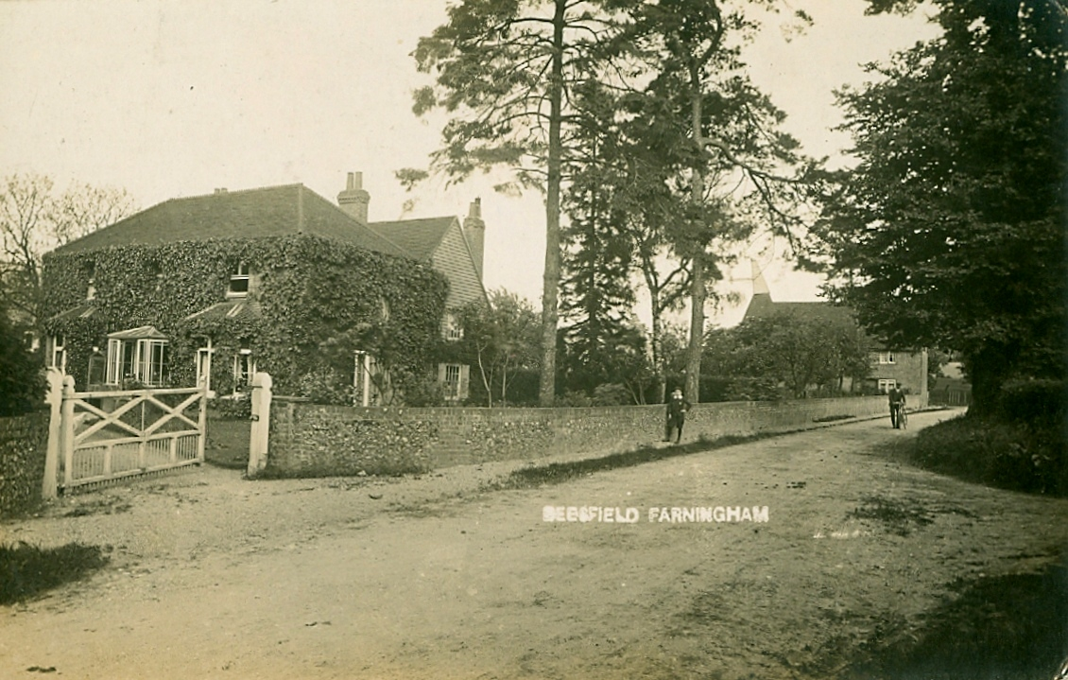

Beesfield Farm, Farningham. (from Kelvyn Tyacke)

A letter from war-time Eynsford
Peter sent a copy of a letter written in August 1944 by his aunt Annie Rogers from Eynsford to cousin Bessie. Annie was born in 1882 and became a teacher. A letter of 1940 referred to a friend, Mrs Bryant, who taught at Sunday School in Eynsford for many years. Annie commented that few teachers were putting forming character in its proper place. 'Now about the doodlebugs, a devilish invention if ever there was one, do you get any? We certainly get our share especially at night. So far none have dropped in the village, but quite near, & the blast from even one does a great deal of damage in the way of blowing out windows, wrenching off doors & bringing down ceilings; there is hardly a house in Farningham with any glass in the windows, a good many people cut by flying glass, but no deaths. Most of the Eynsford children are evacuated to Beer in Devon, & our coloured troops are now gone away, so we are very quiet in that respect. We are surrounded by Barrage Balloons, which bring down quite a lot of the flying bombs. The war news is very good isn't it? It won't be much longer but the last lap is always the worst...'
If anyone can place Annie Rogers or Mrs Bryant please let me know.

Footnote:
200 men, mainly black, from the U.S. Signal Corps were drafted to Lullingstone Castle in the flying bomb period of the war. Lady Zoe Hart Dyke recalled an incident when she returned home and noticed a flickering light in the church. As black-out regulations were most stringent she opened the door to see what was going on. Inside she saw two flickering candles on the altar and dark shapes in the pews praying to be saved from the doodlebugs. Lady Zoe found the Americans delightful guests who showered her with gifts of flowers, cigarettes and tinned food.
(So Spins the Silkworm by Zoe Lady Hart Dyke, 1949)

'This Village was ready for the Nazis'
This was the headline of the Sunday Dispatch report on 22 October 1944 about Eynsford's preparedness for invasion. It showed Mrs E. G. Gaston with a rolling pin, builder W. H. Wellard holding dismantled incendiary bombs, and a pint being downed in The Five Bells. Apparently, the village was on a German map on the line of invasion in 1940, and villagers had plans to hamper the army's passage.
- Grocer & postman S. R. Gee would have destroyed telephone wires and mail
- The Home Guard Platoon Sergeant H. J. Payne & Sergt. J. Hawkins considered that their men had received the finest training
- W. H. Wellard, builder and police chief, said Eynsford's 1,220 population would not have yielded
- Rev. T. H. Groves commented that the village was accustomed to emergencies. 'In the Battle of Britain we never knew what was going to happen next.'
- 82 year-old George Dunster of 9 Willow Terrace, drinking in the Five Bells, said, 'Let them come, they'll find no beer here.'
- Mrs E. G. Gaston, cafe owner and 40 years a cook, had the last word. To German references to the 'wretched housewifery capacities of British women' she replied, 'I would soon have cooked Hitler's goose.'

What happened to Eynsford Fire Station
I was delighted to receive this response from Jean Pilot (Edwards) about the location of Eynsford Fire Station and its fate. Jean's family connections to Eynsford both maternal and paternal go back to 1890, originally through the paper industry and eventually haulage. In fact the Edwards Hall adjoins the former Fire Station site.
'Believing I am the only person still alive who lived less than 100 yards from it as from early 1939 when I was born, I attach 3 photos which will answer your query. Priory Lane in those days forked a little way up (now called Priory Fields) and the Fire Station and Scout Hut were off the right fork. My home was on Fernbank and photo 1 shows me aged probably 3-4 on my swing, the long wooden building on the left side is the Sydney Scout Hut and the part roof on the right was the Fire Station. Photo 2 shows me about 2 years later, part scout hut roof on left above neighbour’s sheet: the house outline behind it was the chalet bungalow and office of R.E.G. Brown and his office: The long building roof behind the swing posts was the Fire Station, and showing inside the right swing post was the mounting on the drill tower for the air raid siren which made one helluva noise when it went off. Photo 3 was the siren mounting. After the War the Fire Station was adapted as a house until Saddlers Park housing was built and the occupants were moved there. It was eventually pulled down and the house Dunhelm built. The Sydney Scout Hut made way for the house now called Pilgrims Rest.
1
2
3
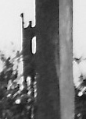
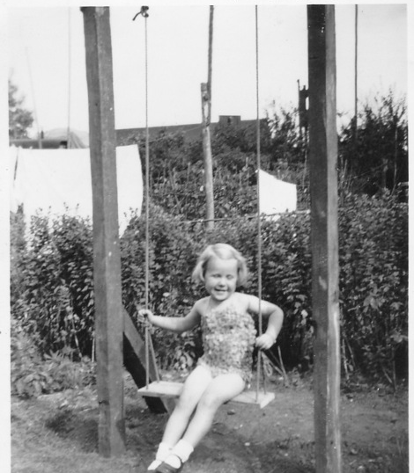
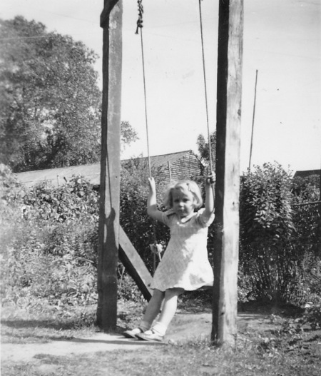

Siren on the fire station (not attached to swing post as it appears, but some distance beyond).

Family History
Baldwin/ Lee - Keith is trying to trace the family back from 1790 when Elizabeth Lee, daughter of Samuel Lee & Sarah Rofe, was baptised. She married William Baldwin of Crayford at Charlton. William was buried in 1823.
Jacqueline Hills - Roger and his wife in Orpington in the 1960s befriended Jackie, whose family they believe lived in Eynsford. They moved back to the Midlands and now would like to renew contact. Please contact me if you know the whereabouts of Jackie or family members who might be able to help Roger.
Edith Lawrence (1875-1964) - Len was seeking confirmation that Edith worked in service at Lullingstone Castle, but I was unable to find a link. There was a 14 year-old Edith Laurence in the 1891 census for Eynsford, living with her uncle and aunt, Elijah and Alice Laurence - Elijah being a farm steward, but Edith was not given an occupation.
Mace of Crockenhill - Steve wanted information on the family, and looking in the Mace folder I was able to make links to other enquirers with whom he could get in touch.
Palmer of Musseden Farm, Horton Kirby - Martin picked up a reference to this family in an earlier Bulletin. I gave him the information provided by Suzannah and Mary with similar interests in the family, but as both were several years ago I do not know whether Martin was able to make contact with them.
Aaron Smith of Crockenhill - My folder on this family is quite bulky and I was able to supply Alan with a portrait of Aaron and other information.

ARCHIVE REPORT
Susan Pittman - 01322 669923, www.felhs.org.uk

After two Mondays back at the Centre in March we were forced to close down. The electrical check was carried out and all was found to be well, although one socket was replaced. The toilet flush was not operating but a plumber has been lined up for when lock-down ends. We still have no-one to take over the Farningham Scrapbook. If you have an interest in Farningham, and are perhaps less active than once, please help out the Society.

Acquisitions
Roy Warman - Newspaper cutting 22 October 1944 'The village was ready for Nazis', see above.
Peter Blackwood - 1944 letter from Annie at Eynsford, see above.
Wilf Duncombe - CD revised Gibson publication; maximum/minimum temperature charts 2014-2019 at 19 Pollyhaugh; 1866 4 lots including Bay Tree Cottages; list of deeds for Joseph Wellard's properties in Eynsford; facsimile copy from 1849 Christening Register, Farningham, statement from the Vicar, Benjamin Winston, & reply from Archbishop of Canterbury; notes on Petham Court; list of news cuttings in Dartford Library; notes on Pawley family of Farningham; extracts from historical journals with local interest. (These came in after I had drafted this Bulletin and will be explored further in the next Bulletin.)

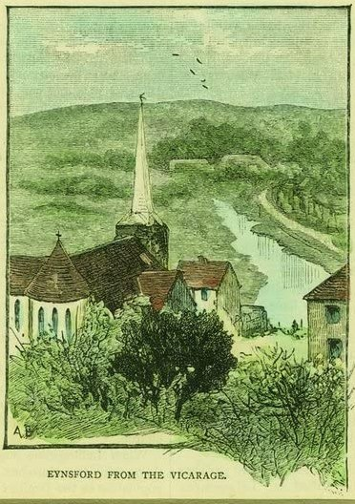
Peter Jones drew attention to this on the internet. 'Eynsford from the Vicarage' 1888.

