Farningham & Eynsford Local History Society
(Original Society founded 1985 Registered Charity no 1047562)
A Charitable Company Limited by Guarantee
No. 5620267 incorporated 11th November 2005 Registered Charity 1113765
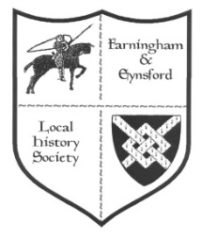

Bulletin No. 123
Spring 2020

MARCH & APRIL 2020 ARE RE-SCHEDULED FOR 2021

22 May - FELHS ANNUAL GENERAL MEETING
Farningham Village Hall
WILL BE HELD AT THE FIRST MEETING ALLOWED AFTER THE CRISIS
List of proposed Committee- Chairman: Veronica Sheppard, Vice-Chairman: Ann Cornwell,
Company Secretary: John Mullen, Treasurer: Vikki Saunders, Minutes Secretary: Helen Smith, Membership Secretary: Alison Marshall, Archivist/research: Susan Pittman, Programme Secretary: vacant
List of proposed Directors: John Mullen (Company Secretary), Ann Cornwell, Susan Pittman, Vikki Saunders, Helen Smith

DECISIONS ABOUT MEETINGS FROM SEPTEMBER WILL HAVE TO AWAIT DEVELOPMENTS

These are worrying times, unprecedented since the flu pandemic a century ago. We wish you all well - stay safe - stay strong - help others when you can

MEMBERSHIP SECRETARY (Alison Marshall 01322 862298)
Although our meeting programme is severely disrupted we urge you to continue to support the Society. The overheads at the Centre need to be met so that we carry on preserving the history of the villages, and we hope to continue the Bulletin as normal.
- Those who still need to renew subscriptions will be sent another renewal form separately.
- Please return completed form to me either by post or by putting them through the door at 11a Riverside, Eynsford, Kent DA4 0AE - it is on the track to the Cricket Meadow.
- Bank account details are on the form to pay by bank transfer. Otherwise please include your cheque or cash in the envelope with your form.

2020 - FORTHCOMING TALKS AND EVENTS
Doors open at 7.30 pm for talks at 8.00 pm on Fridays. Displays of items from the FELHS collection and light refreshments. Members Free, Guests £3.
(Helen Smith 01322 864234)

27 March Eynsford VH Re-scheduled for 12 March 2021
Mystery Artefact quiz - Martin Crowther of Canterbury Christ Church University gives us a quiz night with a difference! He challenges us with multisensory questions - historic recipes to taste, sounds, artefacts to touch and even smell.

24 April Farningham VH Re-scheduled for 19 November 2021
Rural Rides in the Delightful Darent Valley - Christoph Bull introduces us to some of the beautiful places and astonishing people who have lived and worked in the lower Darent valley - Dartford to Farningham.

22 May Farningham VH To be re-scheduled for the next meeting possible
FELHS AGM - AGM followed by a short film of 1988 featuring the work of the Society in its early days; display details to be announced.

Weekend 20/21 Exhibition on local Churches New dates to be found for 2021

REST OF YEAR'S PROGRAMME TO BE CONFIRMED LATER
25 September Eynsford VH
Kent History from the Air - Rod LeGear, a Kent historian, who has been flying out of Biggin Hill for 25 years, will show the archaeology and historical sites in the landscape from the air.

23 October Farningham VH
Lullingstone down the Ages - Susan Pittman will highlight the depth of history over a thousand years or more of this fascinating area.

27 November Eynsford VH
A Mummers' Christmas - The Tonbridge Mummers and Hoodeners will entertain us in this Christmas special event. Singers and musicians perform traditional plays and carols. There will be an entry fee of £6, which will include Christmas fayre.

FARNINGHAM & EYNSFORD LOCAL HISTORY CENTRE
CLOSED UNTIL FURTHER NOTICE
Between Riverside Social Club & Eynsford Cricket Meadow, Riverside DA4 0AE
Open: Monday 9.30 am - noon (from March-November) - and by appointment through the year.
ENQUIRIES CAN STILL BE MADE & ANSWERED IF INFORMATION AT HAND
Enquiries via archives@felhs.org.uk website: www.felhs.org.uk
Come along to visit or to help, or contact us if you have a query. Items (photos, documents, objects, memories, information) can be shared with us. We are adding to the collection all the time, and can copy precious items if you prefer to hold on to the originals. If you hear of anyone looking to dispose of any items of local interest our Centre
would ensure their future, and be of ongoing benefit to the community.

COMMITTEE NEWS
We have been sorry to lose Pat Dee from the Committee owing to family illness. We thank her for her contribution to the Society, especially for the 2020 Programme she arranged before her resignation. We held a successful February meeting and were looking forward to the rest of the Programme, but have been overwhelmed by the pandemic. We hope to resume the meetings as soon as it is safe to do so, and we hope you come along to support our efforts and to enjoy the speakers.

Pat's departure means that we need a new Meetings Secretary, at a time when we need to fill other vacancies on the Committee to share out the various tasks, so that no one has to take on too much. With the AGM coming up do bear this in mind.

We have reviewed our links with our neighbouring Local History Societies - Shoreham & District LHS, Horton Kirby & South Darenth LHS and Hextable Heritage Society -
and have made some changes to an informal agreement made several years ago. We found that we were the only Society publicising others' meetings and offering free entry, so after consultation have decided not to offer free entry, and to give links to the others' websites in the Bulletin rather than giving full details of their programmes. At the same time we have had approaches from Swanley History Group, Otford & District Historical Society, and Anthony Roper Charity. All are now to be linked on our website and added to the contact list in the Bulletin. We are also going to exchange our newsletters.

Lastly, we are delighted to welcome guests to our meetings, but have found that some are becoming regular guests without joining FELHS, so we have decided to charge £3 for guests attending our meetings. We hope this will encourage more people to recognise the benefits of joining the Society to support its work in preserving the heritage of the villages, as well as enjoying its meetings and receiving the Bulletin.

Ever optimistic - we have already booked speakers for the 2021 Programme!

RESEARCH REPORT
Susan Pittman, 01322 669923, archives@felhs.org.uk

Copies of Trident: June - December 2019 wanted for the Centre
We used to be given copies regularly, but the donation has stopped. We have a complete run of Trident until May 2019, so if you have June, July, August, September, October, November December 2019 please think of us. You can drop them through Alison's door. Her address is on the first page of the Bulletin.

Putting paper Trident Index onto Computer - A project to consider
I have compiled a paper copy of personalia in Trident - births, christenings, marriages, anniversaries, deaths, funerals. If you are now confined to your house, or might be, and would like a project, do get in touch. We can arrange to put the paper copy through your door, without contact if necessary.

Membership of Kent Archaeological Society for members of FELHS
FELHS is an affiliated member and as such our members can enjoy certain benefits. If you want to attend KAS events, such as conferences or visits, you can pay KAS membership rates. Contact me for the membership number. I hold the one membership card which you will need if you wish to use the KAS library in Maidstone Museum. You will need to show the card so we can make arrangements for a handover.

Lullingstone Roman Villa at 70, 19 July 2019
I failed to mention in the last Bulletin this reunion of diggers, to which we were invited. A special exhibition featuring the excavations over the years 1949 - 1961 was opened (using some of FELHS display furniture). Brian Philp DL spoke of his involvement as a schoolboy from 1952, and Dr Gerald Cramp of his from 1957 - there were fewer diggers, however, than at the last reunion of 2009. There are community digs taking place this year at Lullingstone Castle led by Dr Anne Sassin, for dates see Darent Valley Landscape Partnership website, which includes Anne's phone number.

Revd. Thomas Browne (c.1612-1678) of Farningham
Tom Reid has sent us a draft copy of a paper he has written about Revd. Thomas Browne gleaned from manuscript (LPL MS 1126) held in Lambeth Palace Library. Thomas Browne was Vicar of Farningham during the turbulent years of the Civil War, when, in 1650, Farningham was a vicarage, with a house, and nine acres of glebe land, worth forty pounds a year, 'Thomas Browne enjoying it, and preaching here.' With the restoration of the monarchy in 1660, Thomas Browne continued as vicar of Farningham, although he was allowed other livings to augment his income. He had managed to ride the storm, and accepted the Act of Uniformity in 1662, swearing allegiance to Crown and Church.

Painting of Eynsford by Walter John Holmes Knewstub (1831-1906)
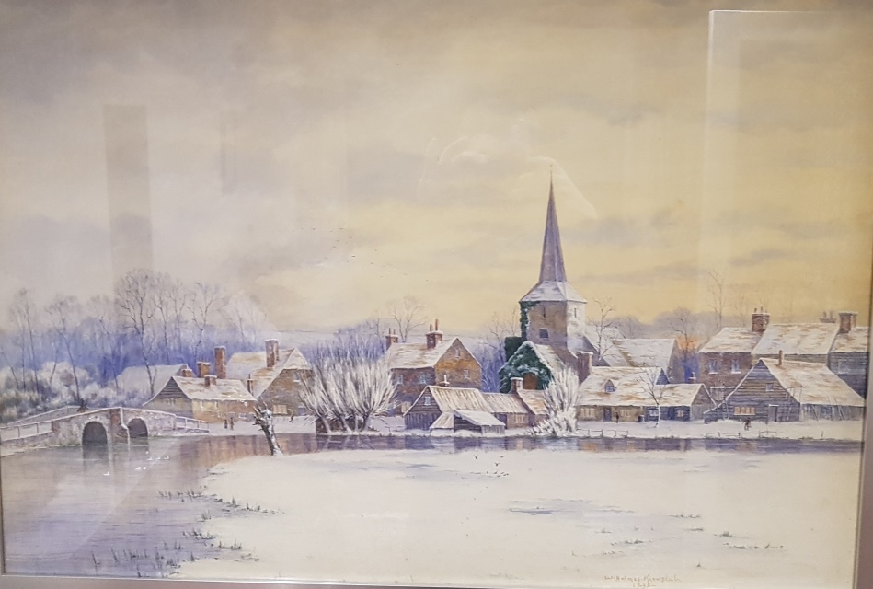

Walter began his career at the Royal Academy School but was so inspired by Daniel Gabriel Rossetti's teaching at the Working Men's College that he left to become his pupil and assistant in 1863. His humorous, easy going temperament fitted well into Rosetti's unconventional household. He became closely involved with the Pre-Raphaelites and married Emily Renshaw, one of the stunning models of the group. (Search Walter Knewstub's name on-line to find a portrait of her and another of their daughter, Lucy, by Knewstub.) The marriage led to a split with the Pre-Raphaelites and he began to exhibit independently from 1865. The painting of Eynsford is dated 1899, so late in his career. It is very evocative and the only image I have seen so far showing the backs of the properties along the river - the one with the cat-slide roof was probably the forge. The painting belongs to Timothy, who believes his grandfather was given it by the artist as repayment of a loan.
Dartford Union Settlement Records
These are loose papers, not individually catalogued. They contain a wealth of information for the family historian:
Herbert Miles aged 8-9 - Father, Edwin, a coachman in Paddington, died of consumption in 1900, and his mother, Clara (nee Stockley) was in Barming Heath Asylum. Herbert was sent to live with his aunt Isabella Stockley of 3 Elliott Terrace in Eynsford. For two years she was receiving two shillings for his upkeep, but he was delicate and in 1909 she asked for three shillings a week as she wanted to keep him.
Charlotte Hayes, widow aged 39 - She had six children under 12. Since 1905 she had lived in High Croft Cottages, Farningham, then at 5 Alexandra Terrace, Swanley Junction. Her husband had been admitted to St. Bart's Hospital in 1909, where he had died shortly afterwards. She had entered Malling Union, and it was asking Dartford Union to pay outdoor relief of 3/6d and sixteen large loaves a week.

Horton Kirby & South Darenth in the Great War
'Our Peace Was Won By The Men Who Fell' by Sarah Lewis, Stephen de Winton, and Malcolm Scott is more than brief biographies of those who died in the First World War, commemorated on the local war memorial and at the Farningham Homes for Little Boys. Half the book goes through the war years as experienced by the local communities, with appropriate photos, ending with the history of the war memorial installed in Horton Kirby Church. One of the men featured is Cyril Munn Crowhurst, who served in the 2nd Battalion, King's Royal Rifle Corps, and died in France of his wounds on 4 November 1918 aged 22. The book says that his name also heads the memorial in the foyer of Eynsford Baptist Church, but this must be another older Cyril, since the one in Eynsford Baptist Church served as deacon and treasurer - hardly likely positions for Cyril Munn Crowhurst to hold as a late teenager when he left to serve.

Harber Brothers Lorries
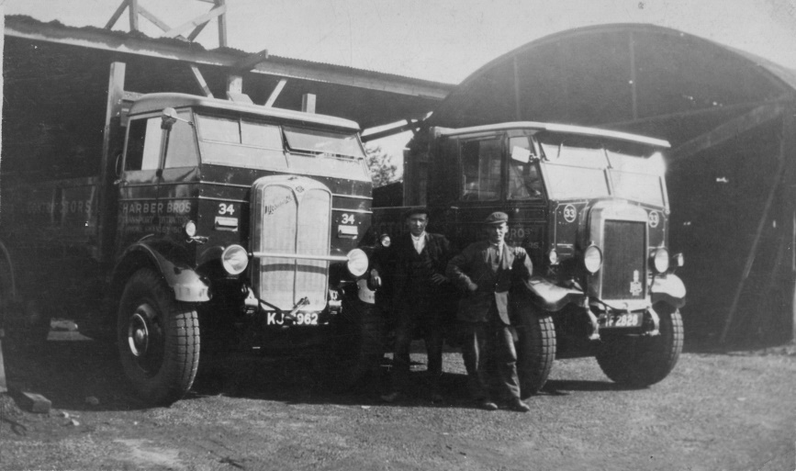
Allan Bedford had written an article about this company, but I did not realise that Norris Willatt had recorded an interview with A.W. Harber in 1938. This has been reproduced in Swanley History Group Newsletter issue 82, November 2019. The brothers began as blacksmiths, but by 1938 had their headquarters in Swanley Village, with four office staff, and forty others. They then owned a fleet of thirty-five lorries and three pits, for shingle, sand and ballast. In 1921 when work on the Farningham by-pass began, the brothers learnt that lorries were required. They borrowed one lorry, and with it went from strength to strength. They supplied 1,000,000 tons of road materials for the Bexley by-pass, and in 1938 were engaged on raising the marshes adjoining the Dartford - Purfleet tunnel. W. Harber attributed
success to hard work and being a teetotaller and non-smoker.
The forge yard depot in the 1930s, (l) AEC Mammoth lorry first registered in 1930/31, and Leyland Bull from 1930. Both models were first introduced in 1929. Standing by their wagons (l) Bob Sloper, (r) Jack Groombridge. (Dawson Sloper)
For more on Harber Brothers see 'The Hauling Harbers' by Allan Bedford and Barry Lucking in Vintage Roadscene issue 222 May 2018.

Eynsford experienced by an Evacuee
Diana Beamish contacted a life member, Robert McCloy, former Director of Education and Chief Executive of the Royal Borough of Kingston upon Thames, when she learnt of Education across the United Kingdom 1944-2017, a book edited by him in 2018. Bob was evacuated to Eynsford during the Second World War and described his experience of attending the village school. He recalled, 'three gas-lit classrooms with coal fires, whitewashed walls, outside toilets, a barren playground with air raid shelter, to which the classes frequently fled to sing 'Ten Green Bottles', or so it seemed.' His father was in the Royal Army Medical Corps stationed in Lullingstone Castle, where they practised military manoeuvres and D-day preparations. 'It was a lively community. It seemed a self-contained world: everybody knew everybody and though there was a recognizably clear-cut social order, ----, all participated in community activities.' The social structure was reinforced by the fact that most secondary school pupils remained in the village, in the former National school building. In 1944 the older pupils were sent to school in Swanley. 'It is doubtful whether this would have been for the pupils or the community a material improvement.'

Eynsford Fire Station
There is agreement that the Fire Station was in Priory Lane. John Meakins believes it to have been built when Dartford Rural Fire Brigade brought the local village fire brigades together in 1931. New engines were then bought and he thinks it likely that Eynsford Fire Station was built to house the new engine - as were Horton Kirby, Wilmington and Stone. When district fire brigades were brought together in the Kent County Brigade in 1948, Eynsford Fire Station lost out in the re-organisation. Its engine was disposed of immediately, and by March 1948 the Fire Station was advertised to be let. Eynsford Parish Council suggested that it be converted into a residence, and rented to an Eynsford family, and perhaps it was
Horton Kirby Fire Station, 1950s
converted into a bungalow. The exact location of the Fire Station is also uncertain - was it on the corner site leading to the allotments, or in the area before the allotment where the Scout
Building and the Parish Council Office stand? Any information would be most welcome.
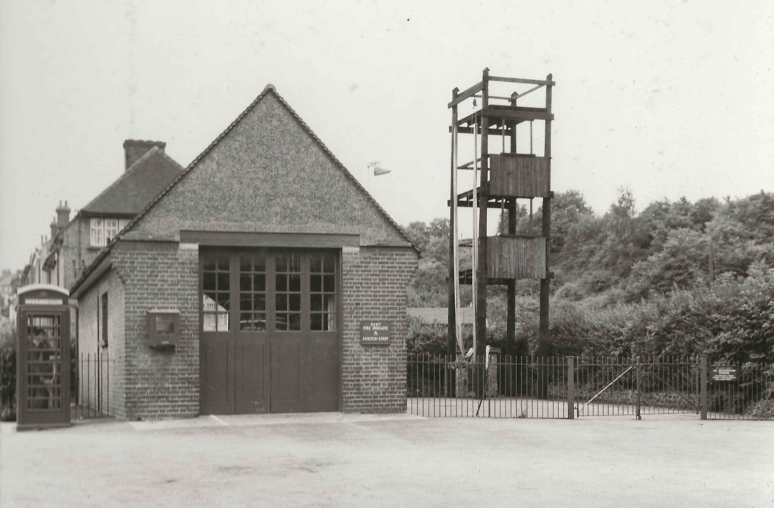

Horton Kirby Fire Station in 1950s.

The Palace of India, Farningham
1874, 1882 Kelly's Directories, 1891 census: Drapers and grocers run by Miss Louisa Gandy.
1913-1924 Directories: Drapers and gentlemen's outfitters run by William Henry Youe.
late 1930s into the 1940s Directories: Mrs Glen's drapery.
1950s - 1960s: Shoe repair business by Mr Howe & draperies / haberdashery by Mrs Howe.
Tea shop for a year.
1980: Spon-Smith Restaurant run by Lynne & David Spon-Smith. Cliff Richard was a diner.
1988: Palace of India Restaurant opened, celebrating its 30th anniversary in 2018.

Shoreham & District Historical Society Publications
I went to a meeting in Shoreham recently and was very impressed by the array of their publications, though they are only a few pages long compared with ours. One I bought was The Shoreham Weather Report, which is of interest since our area would have been similarly affected - the cold winter of 1962-3, the floods of 1958 and 1968, the drought of 1976, the storm of 1987, the snowfalls of 1991 and 2010 are all featured. Look for the full list on the website - also remember that ours are listed under Publications on our website. I think many of you might have forgotten what a wide range of interesting publications we have so I am attaching the full list to this Bulletin. Contact me or Alison Marshall to order.

General Enquiries
Eynsford Workhouse - Stewart wanted to know where this was and when it was used. The workhouse was in Bower House, Bower Lane. It was not needed after the 1834 Poor Law Act which set up large workhouses, and Dartford Union Workhouse was built. In 1846 a meeting of Eynsford ratepayers was held to agree selling the Eynsford Workhouse, and the sale was completed in September 1846 when it was purchased by Thomas Sarjent of Eynsford for £200. (KHLC Dartford Union Minutes G/Da/AM6, pp.382, 385, 392, 396)
Mick Williams - Stephen is researching the Battle of Kangaw in the Second World War for a book and was hoping to get in contact with Mick William's family for some background details. Mick served in No. 1 Commando in Burma, and had memories of the Battle. Helen was able to contact Mick's son, who will liaise with Stephen over his father's papers, and let us know the outcome.
Saxon cemeteries - Chris is digitising archaeological plans for the Darent Valley, and has come across inconsistencies regarding exact locations. I was unable to help him, but sites he has queries about include Darentlea, Castle Cottage and the Riverside Club, all in Eynsford. Please contact me if you know where the archaeology lies in these sites.
Meaning of Farningham - David is researching the Kentish place-name of Frinsted, and its earlier variations. He referred to the possibility of Farningham meaning the place of freemen. I referred him to J.K. Wallenberg's The Place-Names of Kent.
Farningham Hotel - Michael asked for information, which I gave him from FELHS publication on Farningham Pubs. It was built in 1925 from design by J.O. Cook & Sons of Woolwich. The owners of the Bricklayers' Arms bought the two-acre site and transferred their licence to the new-build, after the construction of the new section of the A20.
Cricket/ Football ground near Fort Halstead - John enquired about this. He said there was a well-known story of cricket and football being played on the chalk downs there in Shakespeare's day. I could not help, but noticed in a recent edition of The Sevenoaks Chronicle that Bob Ogley was able to point to one former ground.
Eynsford Fire Station - Garry was interested in the site of the fire station, images of it, and what became of it. (See above)
The Chequers, Farningham - The planned closure of this well-loved pub caused consternation, and FELHS was asked how to get it listed. I suggested approaching the Parish Council to see if it could be classed as a community asset.
Water colour of Eynsford by Walter Knewstub - Timothy wanted confirmation that the painting was of Eynsford. (See above)
Family History
Alexander - Claire from Australia wanted to trace information about Farningham Homes for Little Boys where her husband lived in the early 1950s. I pointed her to our Noticeboard on the website.
Durling - Sue is an expert family historian, who has been studying the Everest family history for years, she enquired about Ellen Sophia Durling (1833-1884) who married Thomas Everest of Farningham in 1852. They had six children before Ellen died of meningitis in 1884, and Thomas married again.
Odd - Caroline asked for details of surviving gravestones in Crockenhill.
Window - Derek's father, Frederic, was sent to Farningham Homes for Little Boys in 1917, aged 9, after his father drowned in the Thames. He sent some of his father's memories, which I suggested he passed on to contacts via our Noticeboard.
Youe's outfitters, Farningham - Michael was tracing his Huguenot ancestors. His great- grandfather, William Henry Youe, kept a shop in Farningham, and died in Thanet in 1927. Vikki was able to supply him the information she had collected for the Farningham Shop Exhibition. (See above)

ARCHIVE REPORT
Susan Pittman - 01322 669923, www.felhs.org.uk
We finished the season last year with a big clean-up so will have a tidy, clean work space for March. Having thought about Health and Safety, an electrical check is being made of the building and its electrical appliances.

During the winter Helen completed adding James Alexander's slide captions to the digital images, and we are hoping to show some of them at a meeting in the 2021 programme.

We will be busy from March to June preparing for the two Church Exhibitions, so any more volunteers would be most welcome.
Members always enjoy the Scrapbooks, but to keep them going we need a volunteer to stick in the cuttings, which I provide. Diana Beamish has been the mainstay for the Eynsford Scrapbook, but we desperately need someone to take over the Farningham Scrapbook. If you have an interest in Farningham, and are perhaps less active than once, it would be a great opportunity to keep up with what's going on, and to help out the Society.

Acquisitions
From Caroline Newbold - The Village of Eynsford c.1910; The Official Guide, Swanley, Kent c.1964.
From Frances Simpson - 1939 OS map 6" to mile from Farningham Road station to Shoreham Castle Farm, and from Cockerhurst to Fawkham Manor.
From Roy Warman - Newspaper photo Farningham Cricket Club v. Lloyds, with Winnie Warman as scorer, ?1970s/1980s (team = Powell, Ward, Pittman, Wood, Collin, Walker, Price, Fenson, Gunner, Trainer, Jayasinghe - any ideas about the year?)

FELHS PUBLICATIONS

1. THE HEARTH TAX RETURNS for Eynsford, Lullingstone & Farningham 1662-1671 £2
2. THE PUBS OF EYNSFORD £2
3. EYNSFORD: 1631-1879 £2
4. LULLINGSTONE: 1659-1879 £2
5. FARNINGHAM: 1659-1879 £2
6. C19TH RAILWAY SCHEMES IN THE MIDDLE DARENT VALLEY £3
7. CARTWHEELS (Lambourne) & CHRYSANTHEMUMS (Cannell) £2.50
8. EYNSFORD WOMEN'S INSTITUTE - the first 75 years £2.50
9. THE CHARITIES of Farningham, Eynsford, Crockenhill & Lullingstone £3
10. withdrawn (A History of Farningham - see no.16)
11. ARCHAELOGIA CANTIANA references Eynsford, Farningham, Lullingstone £2
12. A HISTORY OF THE 1st EYNSFORD & FARNINGHAM SCOUT GROUP £2
13. A VILLAGE AT WAR - EYNSFORD 1939-1945 £2.50
14. THE BOUNDARIES OF THE PARISHES OF EYNSFORD & FARNINGHAM £3
15. EYNSFORD CASTLE - a new history and guide £2
16. FARNINGHAM - a brief history £2
17. MISCELLANY no. 1: Peter Warlock; The Haywards - Eynsford yeomen; Motor
manufacture at Lullingstone; C16th rentals of manors of Eynsford Castle &
Lullingstone; Knatts Valley - farm and name £2.50
18. A SHORT HISTORY OF ST. MARTIN'S CHUCH £2
19. THE PUBS OF FARNINGHAM £2.50
20. MISCELLANY no.2: 1940s Knatts Valley/Eynsford boyhood; Farningham 1st World
War airfield; Bus driver/artist Henry Stockley; 2nd World War Lullingstone dummy
airfield £3
21. A SHORT HISTORY OF ST. BOTOLPH'S CHURCH, LULLINGSTONE £2
22. WALTER GORDON WILSON, ENGINEER & TANK PIONEER £2.50
23. A SHORT HISTORY OF ST. PETER & ST. PAUL'S CHURCH, FARNINGHAM £2
24. out-of-print (Guide to All Souls', Crockenhill)
25. MISCELLANY no.3: Maplescombe Church; Eynsford gun range - armaments &
aircraft; Richard Mullens of Eynsford; Sir Henry Isley, lord of the manor of Farninigham £2.50
26. A HISTORY OF EYNSFORD'S ELEMENTARY & PRIMARY SCHOOLS £2.50
27. FARNINGHAM/EYNSFORD BRIEF HISTORIES of the ASSOCIATIONS, CLUBS £2.50
28. NORTH DARENT VALLEY AS REVEALED BY METAL DETECTING FINDS £5
29. MISCELLANY no.4: The chimneypiece soldiers, Farningham Mill House; William
Dray ironfounder/ farmer of Farningham; Odo of Cheriton Manor, Farningham £2.50
30. out-of-print (Our Bygone Years in pictures)
31. EYNSFORD PAPER MILL £4
32. MISCELLANY no.5: The Limes, Farningham, an Eynsford malthouse; Eynsford Mount
Estate; Farningham races; Sir Anthony Roper - C17th Farningham road closures £3
33. THE BRIDGES OF EYNSFORD & FARNINGHAM £3
34. MISCELLANY no.6: Ft.Lt, Paterson, 2nd World War pilot; Eynsford watercress bed;
Burne-Jones window, Farningham church; Corn mill, Eynsford bridge £3
35. out-of-print (History of All Souls' Church, Crockenhill)
36. RELIEF OF THE POOR - Eynsford, Farningham & Lullingstone £3
37. AN EYNSFORD BOYHOOD 1931-1950 £3
38. ELLIOTT DOWNS TILL 1835-1917 - friend & benefactor of Eynsford £3
39. GIBSON FAMILY of Eynsford & Farningham - Blacksmiths & Ironfounders £5
40. COMMERMORATION OF WARS - Crockenhill, Eynsford & Lullingstone £6
41. C15th & C17th COURT ROLLS - Eynsford Castle, Southcourt & Lullingstone £4
W1. out-of-print (Eynsford walkabout)
W2 FARNINGHAM - a walker's guide free

WHAT’S ON ELSEWHERE IN 2020
Hextable Heritage Society
www.hextable-heritage.co.uk (& on Facebook)
Meetings are held at the Hextable Heritage Centre, Crawfords, Dawson Drive, College
For further information, please Mrs Sharon Mitchell 01322 616424.

Horton Kirby & South Darenth Local History Society
http://hksdhs.org.uk (& on Facebook)
Meetings are held on Monday at the Village Hall, South Darenth from 8 pm.
For further information, contact Barbara Cannell (01322 864253).

Otford & District Historical Society
www.otfordhistoricalsociety.co.uk
Meetings are held at Otford Memorial Village Hall from 7.30pm.
For further information, contact Jackie Howe (01959 525434).

Shoreham & District Historical Society
www.shorehamkenthistorical.org.uk
Meetings are held in the Village Hall Shoreham from 8 pm.
For further information contact the Secretary Lynda Alleeson (01959 525312).

Swanley History Group
www.swanleyhistorygroup.weebly.com
Meetings are held on the first Tuesday of the month, 7.15 pm for 7.30 pm, at The Alexandra Suite, Swanley.
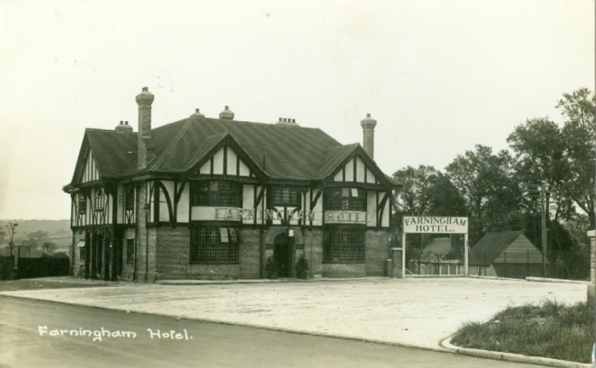
For further information contact swanleyhistorygroup@hotmail.co.uk
Farningham Hotel, newly built in 1925.

