Farningham & Eynsford Local History Society
(Original Society founded 1985 Registered Charity no 1047562)
A Charitable Company Limited by Guarantee
No. 5620267 incorporated 11th November 2005 Registered Charity 1113765
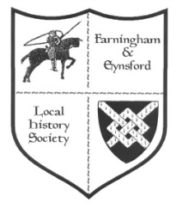

Bulletin No. 121
Summer 2019

2019 & 2020 - FORTHCOMING TALKS AND EVENTS
Doors open at 7.30 pm for talks at 8.00 pm on Fridays. There are displays of items from the FELHS collection and light refreshments. (Helen Smith 01322 864234)
***************************************************************************
2019
20 September Farningham Village Hall
Dirty Dartford by Christoph Bull (discover how Dartford has shaped the very world in which we live)
8 November Eynsford Village Hall
Creep, pull, push - workers on the move by Dr Jean Stirk (the willing or unwilling motives behind the moves, and how to trace moving families)
6 December Farningham Village Hall
Films from FELHS collection - 1968 Floods at Shoreham, Eynsford and Farningham; 1971 Hunt meet at The Lion; Vale in Kent (local scenes including donkey derby); Farningham Youth Club 1960s; 1988 FELHS early days
2020 (to be finalised)
28 February Farningham VH
Topic local to our area to be announced - presentation by Ed Thompson
27 March Eynsford VH
Mystery Artefact quiz with objects brought by Martin Crowther
24 April Farningham VH
'Discover the Delightful Darent Valley' presentation by Christoph Bull
22 May Farningham VH
FELHS AGM - display details to be announced
Weekend 20/21 June St. Martin's Church
Exhibition on local Churches - Main exhibition at Eynsford Church, & at later dates to be announced at Farningham Church & Lullingstone Church
25 September Eynsford VH
'Kent History from the Air' presentation by Rod LeGear
23 October Farningham VH
FELHS evening to be announced
27 November Eynsford VH
'A Mummers' Christmas' plays and songs performed by Geoff Doel & friends
***************************************************************************
HP Laser Jet M2727 printer/ scanner/ copier
This belongs to the Society and is in working order, but has not been used because the inks get damp over winter in the Centre. It is available to anyone who can collect it and give a donation. Contact Susan Pittman

***************************************************************************
CHAIRMAN'S REPORT (Veronica Sheppard)

It is now high summer so make the most of it - the longest day on the 21st June has already passed and we have started to lose daylight, but there are plenty of long days left.

The talk on ghosts by Dennis Chambers stirred up a bit of comment. Joyce Ferrarie said that when she lived at Farningham Mill she was told about strange noises and hand bells ringing. These were attributed to a wedding party that had taken place some 100 years or more ago, when the Vicar had refused to ring out the bells in the church so hand bells were used instead. A small boy appears at the foot of a bed every now and then at Charton Manor Farm! Gerald Roome talks about unexplained noises in Farningham church. In the 1930s Harold Ingram was poaching in Lullingstone Park when he saw a lady glide across Lullingstone Castle lawns and disappear through a brick wall. When relating this experience he found that others had seen this ghost, though until then he had never heard that Lullingstone was haunted. In the Guide Book 'Along the Darent Valley Path' published by KCC in May 1997, there is an account of a young Elizabethan lady haunting Franks Hall. There is no evidence that Elizabeth I stayed in the mansion, but the ghost story seems to depend on such a visit.* It is rumoured that the Queen disapproved of the romance between one of her ladies-in-waiting and a local yeoman. Later, the unfortunate young woman was found dead in the shrubbery on the banks of the Darent. Perhaps she drowned or was murdered, but her ghost is said to rise from the river in August to walk across the lawn. Keep a lookout in August!

We had a very good day at the Farningham Fete, lots of visitors came to ask about goings on with FELHS, and of course the photographs always stir up a lot of interest. The AGM has been and gone with the election of the same Committee now including two who had been co-opted after the last AGM. We also have more Directors who are also Committee members.

Hope to see you all at the next talk in Farningham 'Dirty Dartford' by Christoph Bull.

* 'The Portable Queen' by Mary Hill Cole (University of Massachusetts 1999) lists all Elizabeth I's overnight stays, but none are mentioned for Franks Hall. The Queen had sleep-overs in Dartford in 1573 and 1582, and at Scadbury (Chislehurst) in 1597, which seem to be as near as she got to our villages.
FARNINGHAM & EYNSFORD LOCAL HISTORY CENTRE
Between Riverside Social Club & Eynsford Cricket Meadow, Riverside DA4 0AE
Open: Monday 9.30 am - noon (from March-November) - and by appointment through the year.
Enquiries via archives@felhs.org.uk website: www.felhs.org.uk
Come along to visit or to help, or contact us if you have a query. Items (photos, documents, objects, memories, information) can be shared with us. We are adding to the collection all the time, and can copy precious items if you prefer to hold on to the originals.

RESEARCH REPORT:
Susan Pittman, 01322 669923, archives@felhs.org.uk

New publication - 'The Lee farming family of Crockenhill Kent' by Susan Pittman
This new book is the second of a planned series of five researching aspects of farming in Crockenhill. It has 132 pages and is lavishly illustrated. It relates the fascinating story of Caleb Lee & Sons (1840s-1980s), who pioneered cold storage of fruit in the U.K. £12 (+£2 post and packaging). Available from Crockenhill Parish Council, Crockenhill Village Hall, Stones Cross Road, Crockenhill, Swanley, Kent BR8 8LT (01322 614674).
The first book about the Miller family of Wested, once the country's largest grower of peppermint is also available at £8 + £1.50 p&p.
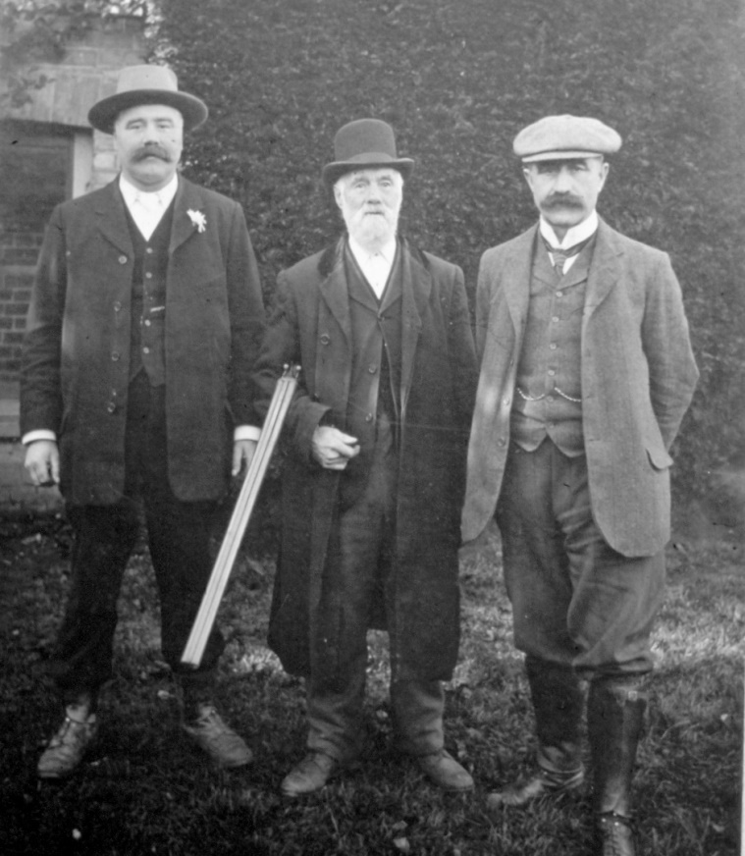
Caleb Lee with his sons, Archibald (left) and Sydney (right), a few years before Caleb's death in 1918. (Clements archive)

South East Research Framework Resource Assessment and Research Agenda
Kent County Council consulted in March on this rather wordy-titled document, drawn up in combination with Surrey and Sussex. It makes fascinating reading with a summary of the heritage legacy left in Kent from the Palaeolithic age to modern industrialisation. I have copied parts with local references on the Roman and Anglo-Saxon periods for the Centre. However, the full document is still on-line at:
https://consultations.kent.gov.uk/consult.ti/SERFstageone/consultationHome

List of 2nd World War bomb sites in Eynsford and Lullingstone
120 incidents were recorded in Eynsford and Lullingstone from 1940-1944. Four bombs were listed for Lullingstone. The first incident was on 5 September 1940 over Lullingstone Park when the pilot baled out, and a day or two later another crashed plane over the Park brought down overhead electricity cables. The last incidents were of flying bombs on 9 & 11 November 1944, one exploded in the air over Lullingstone Park damaging the Castle, Church and estate buildings, while the last did light damage at the top of Bower Lane.
(Original list held by Dartford Library)

Update from Jean Hynard, aged 92, Lower Austin Lodge Farm
I visited Jean and her daughter, Joscelyne, near New Ash Green, and spent a pleasant afternoon with them. Jean married Gordon (1920-1969) in 1950 and they had four children - twins Sarah and Joscelyne in 1951, Jonathan in 1953 and Timothy (1964-2018). When Gordon died Jean continued to manage the farm, but none of her children wanted to take it over, so she moved out and bought a more manageable place. I looked at the 1949 diary mentioned in the last Bulletin and was allowed to copy it for the Centre. It is mostly a working diary:
January Dispatching bags of potatoes and Savoys
February Dispatching bags of potatoes and Savoys; tree washing
March Discing; ploughing
April Drilling; rolling; bean poles put in; tree washing; potato rolling; spreading fertiliser
May Spraying; cultivating; tree washing; bean planting; harrowing orchard, potatoes; hoeing
June Hoeing; spreading fertiliser; harrowing; rolling; hay turned; 6 cows arrived
July Planting Xmas cabbage; bean twiddling; spraying beans against greenfly; picked Beauty of Bath apples; 11 cows and milking cows taken away
August Wheat binding; combine barley; corn cleaning; bean picking; apple picking; threshing; bale carting
September Picking sweet corn; barley taken to Fremlins Brewery; lucerne combined for Alexander at Manor Farm, Farningham; clover cut; apple and pear picking
October Ploughing; apple picking; cabbage weeding and picking; ploughing; thatching; bale stack; pulling mangels
November Harvesting potatoes and Savoys; carting dung; seed wheat delivered; 6 bullocks arrive out and then into yard; ploughing; threshing barley
December Ploughing; dressing barley for seed; 13 cattle arrived; drilling; dung spreading; 3 days off over Christmas;
In 1951 the farm had 4,200 apple and pear trees of the following varieties; Pears = Conference, Comice, Fertility; Apples = Lambourne, Worcester, Newtons, Cox, Ross, Rival, Bramley, Peasgood.
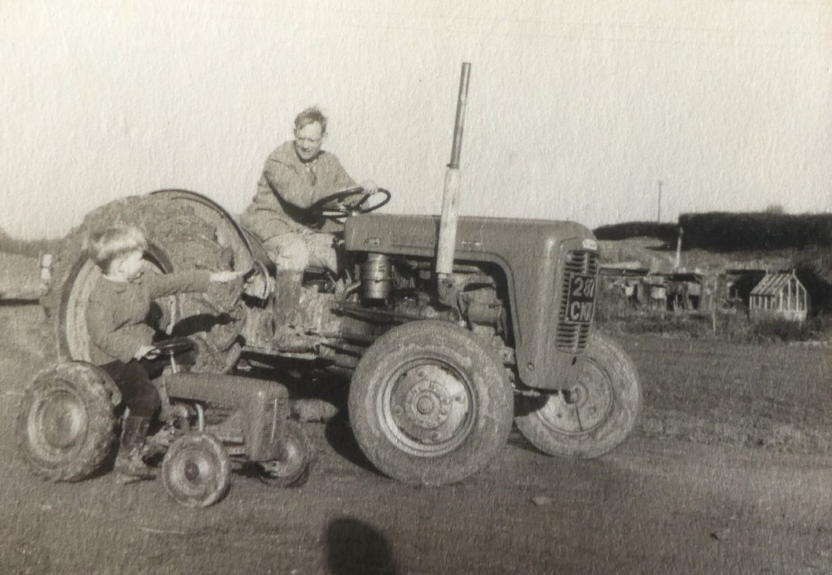

Gordon Hynard on his Massey Ferguson 35 with his son Jonathan on a miniature version built for him by his father, August 1955.

Loftus Edgar Lambourn's unusual will, 1915, more about Rose Marchant
Barbara Cannell has looked up Rose Marchant in the 1881 census for Farningham and found her, aged 10, the second daughter of Henry Marchant, a wheeler aged 44. The Marchants were living in what was then Church Street. Nearby was an uninhabited public house, which might have been The White Hart, and Louise Lockyer's Seminary. According to Hilary Harding, Henry Marchant was in business with Thomas Everest from the 1860s. He lived in Parsonage House and later built Hillside. His daughter, Rose, lived there until her death in 1939. As a keen member of the Wesleyan Chapel she is to be seen in this photo along with the congregation in front of the building. Henry Marchant became very rich, and Rose remained unmarried so perhaps she had no need for Lambourn's bequest.

(See also Farningham Mill by Hilary Harding p.276 & 277 and FELHS publication no.7 Cartwheels and Chrysanthemums pp.1,2 & 7 - the cartwheels referring to Lambourne's, Wheelwrights of Farningham)
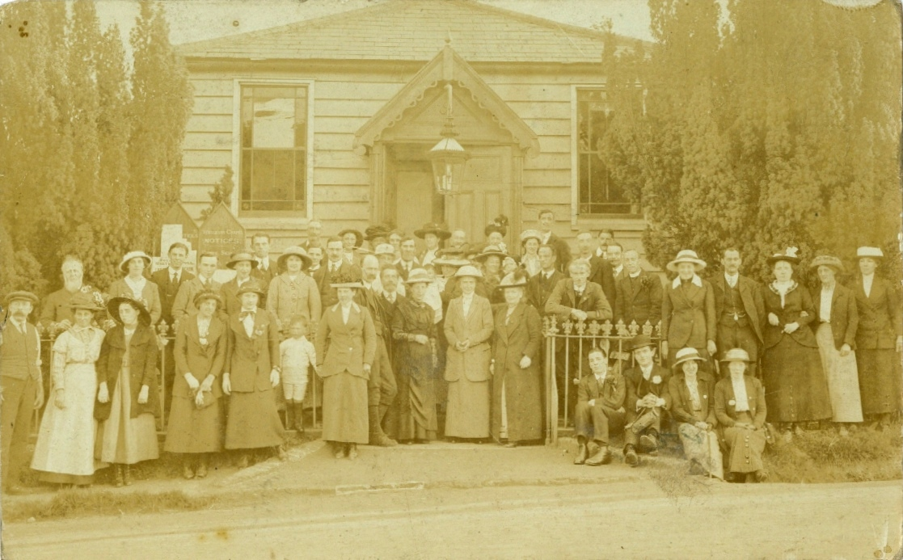
William Moore, who built the chapel, far left with beard, Rose Marchant centre left foreground, Mrs Len Waller holding baby. The postcard is dated 1914 and mentions the Chapel's anniversary - perhaps 1900 for its 50th or 1910 for its 60th. (from Kelvin Tyacke)
(See also p.234 in Farningham Mill by Hilary Harding)

Serious accident to Joseph Baldock when chaff-cutting, 1914
Joseph Baldock, described as an old man, had a terrible accident while chaff-cutting at Pedham Place Farm, Farningham, owned by Sheridan Wood. Joseph was working the machine when his left arm was caught up into it, severing his hand and severely injuring his upper arm. No doctor could be found, but he was attended to by Mr Wood's nurse before being taken to Cray Valley Cottage Hospital.
(St Mary Cray & Orpington District News 30 October 1914 - supplied by Barbara Cannell)

Eynsford Cricket Club 1891
A short item in the Dartford & District Times of 3 July 1891 begins with the following: 'The Squire of Lullingstone is a real cricket man, although he never manifested any disposition to introduce the game into the Education Code as part of a boy's (or girl's) outfit.' This reference is to his office (1887-1892) as Vice-President of the Committee of the Council on Education. The reporter went on to recount Sir William's allowing Eynsford Cricket Club to 'take possession of a charming piece opposite the Plough Inn and abutting on the Darent stream. The piece is a cricket ground of cricket grounds - spacious, flat, and commanding a view of one of the finest landscapes in Kent.'

The Decline of Farningham Market, 1888
A meeting was held at the Bricklayers Arms to consider altering the time and date of the Market, and to decide ways of gaining better support from farmers and cattle salesmen. Diminishing support was blamed on recent cattle disease which had led to the closure of the market for some months. It had not helped matters that Sevenoaks Market had chosen to alter its date to the same day as Farningham's. The meeting decided to change the day to the second Wednesday of the month, but it was felt that with the depressed state of farming, Farningham market might never return to its previous success.
(Bromley & District Times 25 May 1888)

General enquiries
Water leak by Eynsford village sign - A parish councillor wanted any information about the former drainage system of the vicinity, but I was unable to help.
Historic flow of the River Darent - Visit to the Centre by Dr Chris Gardner of South East Rivers Trust who is researching the subject.
History of Eynsford Scouts - Visit to the Centre by Terry, leader of the Scouts Group, he took some time to go through what we hold on the Scouts.
Pictures of the inside of Lullingstone Castle - Ann wanted copies for a U3A talk she was giving. I hesitated because of the uncertainty of copyright and she obtained images from the Internet instead.
Gibson horse engine - Dave from the Rural Life Centre at Tilford, Farnham, Surrey, sent photographs of a S.W. Gibson horse engine that had recently been donated and restored. He wanted to know more about the Company. I found no reference to a Gibson horse engine, but sent Wilf Duncombe's FELHS publication The Gibson Family of Eynsford and Farningham: Blacksmiths and Ironfounders.
Local historian - Yvonne wanted to be put in touch with a local historian for the area. I replied that she had found one, and asked for more details of her interest, but she has not replied.

Family history enquiries
Booker - Peter and Elizabeth from Essex paid an unexpected visit to the Centre. They copied several items, but have not sent a promised family tree for me to connect them to other branches of the family.
Bowers/ Hearn/ Pocknall - William sent me pages of typed notes about the Bowers family, who lived at Riverside Cottage, Eynsford. He does not know who did the research. It begins with George Bowers born in West Wycombe in 1770 and arriving in Farningham in 1805. He immediately became associated with helping Eynsford Baptists to build a new chapel. (I will write more about this in the next Bulletin.) The family is followed to 1947. A copy photo shows 7 named members of the family outside Riverside Cottage in 1960.
Peach - John wrote from Delaware, USA, saying he was the last of the Peach Delaware line, who came to USA between 1682 and 1737. He wanted to know how to find what ship the family sailed in. I have put him in touch with John H. Peach in USA, who runs a website devoted to Peach genealogy and has written twelve books on various lines - hopefully he has already come across the Delaware branch.
Shamblin - Dennis from Arkansas, USA, wanted help in meeting distant relatives in Britain - the list of his ancestors included Ann Boleyn, Alexander II of Scotland and Edward II of England. I suggested he send me more recent family connections - I could hardly arrange a meeting with the Royal family for him!

ARCHIVE REPORT (Susan Pittman - 01322 669923 www.felhs.org.uk)

The Centre has been busy since it opened after the winter break in March. We have another batch of slides from James Alexander's slide collection to input the captions into a digital catalogue. We have been preparing displays at our meetings and for various local events.
The overhead water leak has been repaired, but the plumber noticed rat droppings and some gnawing of the insulation and so this had to be dealt with. Having the plumber go up into the loft was therefore a blessing in disguise! The roof tile has also been replaced, so let's hope the batsmen don't aim our way this year!

Acquisitions
From Peter Doye via Philip McGarvey - 'Old English Houses' by Hugh Braun; 2 bound volumes for Anthony Roper Charity, parish of Farningham - Minute Book 1909-1962 covers the distribution of doles, list of over 70 to whom coal was distributed (in 1911 these included Joseph Baldock of Pedham Place - so before his accident in 1914), prizes for good school attendance, by the 1960s about four people were given regular dole pensions; Journal 1947-1969, the front has accounts e.g. for 1969 income was £423+ and £3/10 shillings paid out each week in dole pensions, and later in the Journal Minutes for 1971-1982. (These items have been deposited at Kent History and Library Centre to be added to other Anthony Roper Charity archives held there)
From Vivienne Parker - 1909 25 inch to the mile OS maps x3 - Maplescombe and Chimhams area; Beesfield to Gabrielspring Wood; Franks to Eglantine; Tracing 25" to mile from Pedham Place to just east of Farningham High Street with field names, acreages and cropping, new A20 and Oliver Crescent built so post-1925 and no village hall so pre-1938.
From Judith Rixon - 5 postcards of Eynsford, one from a painting by Pat Needham shows the church spire and village beyond from higher ground.
From Kelvin Tyacke - Down by the Darent by Walker Miles, 1890s pp.13-14, 20-84. This was incomplete, but I have been able to photocopy the missing pages from elsewhere. It includes woodcuts of Eynsford castle and the bridge/ford scene.

KENT HISTORY FEDERATION DISSOLVED
KHF was founded in the 1960s, but recently although 100 or so local history societies located in Kent were members, it has proved impossible to recruit new Committee members. Sadly, when after years of service, Revd. Dr Peter Rowe, Jackie Grebby, Dr Maurice Raraty and Robin Thomas, stood down no replacements came forward, so on 3 June 2019 the Federation was dissolved. Several of you will miss The Journal of Kent History and the annual conference in May held at various locations throughout the county.

WHAT’S ON ELSEWHERE IN 2019

Members of FELHS can attend free of charge if they bring proof of membership, e.g. email or other receipt of subs, or life membership card.

Horton Kirby & South Darenth Local History Society
http://hksdhs.org.uk (& on Facebook)
Meetings are held on Monday at the Village Hall, South Darenth from 8 pm.
For further information, contact Barbara Cannell (01322 864253).
8 July Lost Empires – the last days of Music Hall and Variety – Wilf Lower
9 September To be confirmed but will be a talk by a member
11 November AGM & Short Talk followed by Wine & Cheese

Shoreham & District Historical Society
www.shorehamkenthistorical.org.uk
Meetings are held in the Village Hall Shoreham from 8 pm. Members who wish to attend these meetings are advised to contact the Secretary Lynda Alleeson (01959 525312) to check that no changes have been made to the programme.
20 September The Bevan Boys - Dr Ann Kneif
18 October Unravelling the Yarn (Lullingtone silk) - Claire Weiss

Hextable Heritage Society
www.hextable-heritage.co.uk (& on Facebook)
Meetings are held at the Hextable Heritage Centre, Crawfords, Dawson Drive, College Road, Hextable from 7.30 pm.
For further information, please Mrs Sharon Mitchell 01322 616424.
8 August Medway Tales- The Dividing River - Wilf Lower
12 September Cockney Culture - Mick Tilling
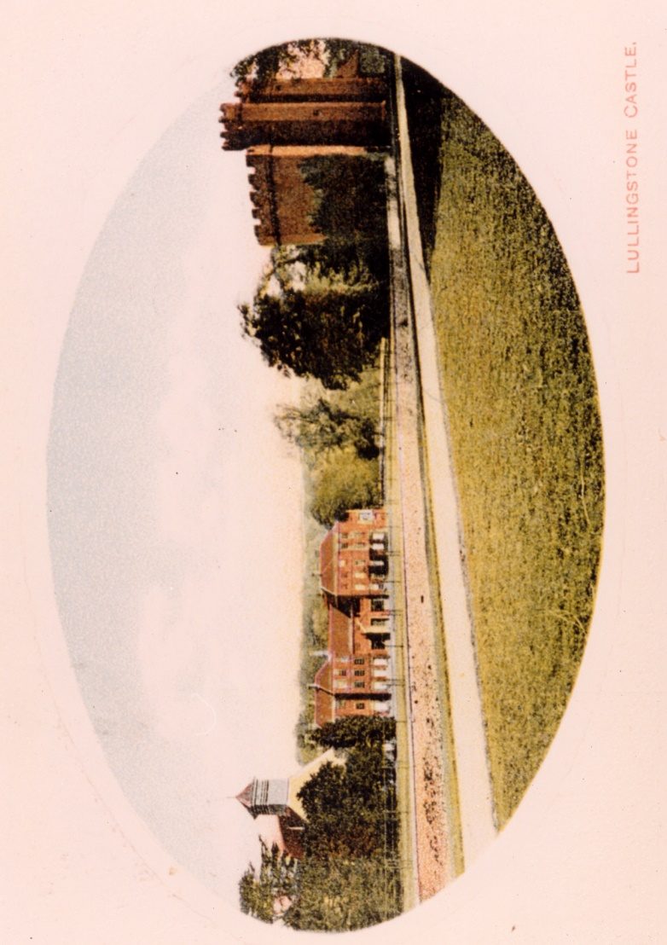
10 October Bletchley Park - Ian Thomson
14 November Victorian Leisure - Ian Bevan
5 December Christmas Social evening

