The Farningham & Eynsford Local History Society
Founded 1985
A Charitable Company Limited by Guarantee
No. 5620267 incorporated the 11th November 2005 Registered Charity 1113765
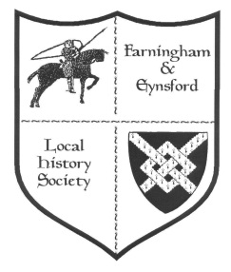
(Original Society founded 1985 Registered Charity no 1047562)
Bulletin No 107
September 2015
Forthcoming Talks and Events
2015 Details Where
18th Sept The Gentlemen at War – Roy Ingleton EVH
23rd Oct Unexplained Mysteries and Cover-ups – Andy Thomas
(Ticketed evening including buffet supper) FVH
27th Nov Waterloo 200 – Steve Hookins FVH
31st Oct Eynsford Pubs Then and Now 1230am – 430pm Castle
(Display of items from the archive centre) Hotel
2016
26th Feb To Wilhelm with Love – Steve Hookins EVH
20th May AGM FVH
7th Sept Trip to the Kent Battle of Britain Museum and
Battle of Britain Monument at Capel le Ferne (full details
of the day will follow)
23rd Sept World War One poets – Bob and Fern Ogley FVH
11th Nov The Crystal Palace Story 1854-1936 EVH

Unless otherwise stated all Meetings are held on a Friday evening from 730pm, talk commencing 8pm. (Note: front row seats can be reserved for members with hearing or eyesight difficulties and hearing loops are now available on request)
REPORTS FROM COMMITTEE
CHAIRMAN’S REPORT (Barbara Cannell 864253)
Two events that Jan and I representing the Society, have been involved with for several years now are the North West Kent Family History Society AGMs and the Farningham Church Fetes. On both these days we enjoy meeting people who, like us, are interested in family and local history. Our displays are usually reminders of the past and we often find that this encourages a response from the public with a story from their own family history or something that happened in the local area. We always leave these meetings having learnt a little more which means we can add more information to our displays.

This year the NWKFHS AGM was held at the Sevenoaks Community Centre and our display was based on how we gather together information from various sources to add to what we already know. The occasional postcard bought from eBay and from letters requesting one of our publications and of course the discovery of the Alexander Pitcairn mausoleum in St Martin’s Church, Eynsford led to some interesting research.

The Farningham Church Fete held on 6th June was the first time I didn’t use the display boards as in past years the wind would always blow them down. I just laid items on the table tops. It meant that there were not so many pictures to look at but I had put pictures into an album that was easy to use. Jan was unable to be with me this year but I thank Dee and Alison for spending time at the display. Farningham publications were available for sale and also ball point pens with the FELHS logo (there will be a chance to buy a pen at our next evening meeting in September)

RESEARCH REPORT (Susan Pittman 01322 669923) (www.felhs.org.uk)
Save our Sounds
The British Library has launched a programme entitled' Save our Sounds' to preserve as much as possible of the nation's rare and unique sound recordings from collections across the UK. We are taking part in a National Audit of UK Sound Collections by informing the BL of the items we hold in our collection. These include tape cassette interviews with villagers dating from the early years of the Society, but there are also recordings of the church bells at Farningham and Eynsford.
The 1939 Register
Shortly after the outbreak of the Second World War the government gathered information about the civilian population so that it could organise the issue of identity cards, ration books and so on. The Register bridges the gap between the 1931 census (details of which cannot yet be released), and the never-taken 1941 census. The 1939 Register is shortly to be released on-line - to learn more look at the Genes Reunited website.
(Thanks to Peter Jones for this)
New HQ for Toc H Eynsford Branch, 1963
The Vicar of St Martin's allowed Toc H to have the stables and coach house of the old vicarage as its headquarters. The branch restored, decorated and furnished the premises and laid out a garden. The new headquarters was opened at 6.30 p.m. on Saturday 31 August 1963 by Mr F. Penwarden, followed by a short service of blessing conducted by Revd. Tuffin and Revd. Hallworth. Later in the evening a social and dance was held in the Village Hall.
Obituary for William Alexander O.B.E., 1957
'Kent Farmer' in April 1957 printed an obituary to William Alexander who had died at Home Farm, Eynsford, aged 74. By the time of his death he had earned a national reputation through his agricultural knowledge and successful farming methods. He had started at Eynsford in 1912 with 160 acres and ended with 1600 acres. He was especially known for his British Friesian herd, one bull 'Eynsford Archer 13' sold for a record five thousand guineas in 1954. He also pioneered the growing of lucerne on thin chalky banks. He was awarded an O.B.E. in 1948 'for services in the design of new and useful agricultural machines.'

Bower Farm Training Centre, Bower Lane, Eynsford
Those who came to 'Our Villages in the Great War' Exhibition might recall that both Park and Bower Farms were taken over in the First World War and became training centres for disabled servicemen. (See now FELHS website WW1 for the Exhibition display sheets). In 1921 the farm took part in trials of potato varieties organised by the Kent Agricultural Education Committee, the sprouted potatoes sown yielded heavier crops than the un-sprouted ones.
The Kent Farmers' Union Journal of 1921 printed a letter from E. Taylor referring to a £5 prize awarded by the Maidstone Branch of the NFU for trainees learning thatching, sheep-gate making, hedge laying, and fencing etc. Mr Taylor and Mr Bellingham had acted as judges and found the standard of skills reflected great credit on management and workers. The men spent a year at the Centre and many were restored to health by the fresh air and healthy surroundings, combined with interesting and practical work to occupy their minds. Mr Taylor's letter implied that there were some who thought public money should not be spent on the training, but he disagreed. The skills the men acquired gave them independence and could be used to give them an honest living. Mr Taylor strongly advised farmers looking for a permanent hand to seek one from the Centre first.
North Kent Ploughing Match at Farningham, 1913
This was a transitional period with horse-pulled ploughs, steam driven ploughs, and the newer 50 h.p. 6 furrows motor plough. One photograph caught my attention - subsoiling by explosion, which seemed a drastic way to disturb the ground. A Cheddite cartridge, which took two minutes to explode, and 'attacked' the earth within a radius of 5 feet, was used. With the outbreak of the First World War within the year, I doubt that this practice caught on.
Farningham Golf Club, 1912
At the June meeting of Eynsford Parish Council it was reported that the Club intended to play seven days a week and a resolution of disapproval was passed, and Mr E G Stevenson was to be approached on the matter. (This was the nine-hole course which had been created alongside Sparepenny Lane.)
The Castle Hotel Guest Book
Keith came over from University of Guelph in Canada to see the Guest Book, reference to which he had picked up from the Internet. He is studying hotel guest books and was fascinated by the drawings and poems included in this one. I took him to lunch at The Castle and showed the Guest Book to the owners. I had not before thought about the context of the Guest Book, but now realise that it was new in 1904 when Elliott Downs Till took over the establishment, until then known as The Harrow. Till renamed it and took it up-market from pub to hotel, with an impressive new bound guest book to match its enhanced status.
Eynsford stocks, Bower Lane
Browsing in the Kent History and Library Centre at Maidstone I came across 'Dartford and Neighbourhood' by Charles J. Redshaw, published in 1911. In it I was pleased to see a photo, which I don't recall seeing before, of the Eynsford stocks in situ in the triangle of land at the bottom of Bower Lane. In the background were Fountain Cottages. There also appears to be a village pump at the High Street end.

The Five Bells, Eynsford and The Chequers, Crockenhill
In an attempt to find out more about The Railway Tavern, Eynsford (see Other Enquiries below), I checked up on documents cited in Wilf Duncombe's publication 'The Pubs of Eynsford'. In a mortgage document of 1870 (KHLC U1833 T107), the plans of 18 pubs owned by Tasker's Brewery of Dartford included two local pubs. The Five Bells had a large garden and a coach house/stable block. It had formerly been in the occupation of William Brand, but in 1870 was run by Eliza Brice. The Chequers in Crockenhill had a large garden, yard with WC (ash pit) and stable, and was occupied by Charles Waller. For those interested in the full layout and individual uses of buildings in a working brewery, the plan of Tasker's Brewery in Dartford would be of great interest, with at least 38 outbuildings shown and labelled, e.g. pale ale store, porter store, ale store with chaff store over, malt store over kiln, bottle store, cork room, tun store, and principal's office.
Farningham in the 1630s - Sir Anthony Roper gets his comeuppance
Wilf Duncombe in FELHS publication no.32 wrote a paper on some road closures that Sir Anthony Roper forced through in Farningham in the first decade of the C17th. His disruptive streak did not stop there, and he went on to cause further distress in Farningham until he was eventually summoned to the Court of Star Chamber in 1636. There he was accused of pulling down three farmhouses in Farningham and allowing two others to fall into disrepair, after evicting the tenant farmers and converting arable land into pasture. He had also pulled down a water corn-mill which had previously sent grain from the farms to London. As a result of his actions many poor men and women were unemployed, and Farningham was becoming depopulated. He was found guilty as 'a great offender, and fit to be severely punished'. He was therefore fined £4000, sent to Fleet prison, and had to stand in the Assize Court publicly to acknowledge his offences. He also had to pay the costs of the suit, pay £100 to the Minister at Farningham, and £100 to the poor there in recompense for their suffering. He was given two years to repair and rebuild all the farmhouses with their outbuildings, and the corn mill. Lastly, he had to restore 600 acres of land to its former use, and to let the farms and corn mill out at reasonable rents.
('Dartford and Neighbourhood' by Charles J. Redshaw, published in 1911 - based on Hasted's 'The History of the County of Kent, 1797, volume 2, p.515)
KCC consultation about turning the Library, Archive and Registration Service into a Trust
The report following the consultation did not adequately cover the representations made about the deep misgivings local history groups, researchers and professionals had over the fate of the archives under a Trust. However, the project has been put on hold because it has been realised that the Registration Service under current legislation cannot be put into a Trust, and apparently it is difficult to take it out of the package. Personally, I would have thought that KCC should have been better advised before going ahead with the consultation, which has cost a great deal of money to conduct.
Family history enquiries
Chittock - Fran enquired about the Chittock family from 1810-1841, but I only found links with St. Mary Cray where a headstone names Sarah, wife of Edwin Chittock, who died in 1850 aged 42, the second daughter of William and Sarah Hardstone. Fran told me that Edwin Chittock was the governor of St. Mary Cray Workhouse in 1841, and that his wife was the Matron.
Kingsland - Sharon from New Jersey USA wanted to get in touch with John from Canada who had enquired about the Kingsland family early in 2014. She had found the reference in our Bulletins on our website.
Salmon - Michael wanted to go back further than Mary Ann Salmon, daughter of William and Maria, baptised in Eynsford in 1790. Mary Ann married John Castleton in Darenth in 1812. I was unable to help.
Other enquiries
1920s/1930s Images of Eynsford Paper Mill - Peter is a forensic paper historian researching Eynsford paper used by the artist, Winifred Knights (1899-1947). He has sent an image of one of her watercolours of an Italian scene from the early1920s. Winifred died aged 48, completing few major works, but her altarpiece for the Milner Memorial Chapel completed in 1933 can be seen in Canterbury Cathedral.
4 Elm Cottages, Eynsford - Adrian wanted to know the history of his cottage, which had once been called 'Railway Tavern'. I looked in Wilf Duncombe's publication 'The Pubs of Eynsford', finding that the only reference to the Tavern was on a plan of 1864, which I eventually tracked down in our collection, and copied to Adrian. Should he later produce copies of his house deeds then a further line of approach would be to look up owners through the ten-yearly census records.
Paintings by D.G. (Bill) Burcham - Kevin has inherited from this father-in-law a water colour of Scotney Castle by Bill, and wanted information about the artist. Bill wrote FELHS publication on 'Eynsford in the Second World War', and illustrated the Eynsford walkabout among other things. Bill was a building surveyor for one of the London Boroughs and served as a bomber pilot in the Second World War. I offered to contact his widow, but Kevin has not got back to me.
Percy Pilcher - Sarah's friend was interested in Percy Pilcher, and she enquired about FELHS publications on the subject. I referred her to Wilf Duncombe's paper in publication no.25 - Miscellany - 'The Eynsford Gun Range; Armaments and Aircraft'.
Firmingers Road, Well Hill - Helen, surnamed 'Firminger', who lives in the road asked about the origin of the name. As it is just out of our area I passed the enquiry to Geoffrey Copus, whose area of interest is Chelsfield.
Crockenhill and Farningham Parish Councils - The Councils have asked advice on the deposit of some of their archives.
ARCHIVE REPORT (Susan Pittman 01322 669923) (archives@felhs.org.uk)
FELHS Centre
Thanks to the invaluable input of the working parties (comprising Helen, Vikki, Ann, and Alison) steady inroads are being made into sorting the uncatalogued items. One of the four drawers has been cleared, and I have sorted the other three drawers to fill one drawer to the brim!! The more help the better, so if you feel tempted to give it a try do drop in on Mondays (not Bank holidays) between 9.30 am - 12.00 pm. You can take pot luck or, just in case of unforeseen circumstances the session is cancelled, check with me or Alison Bridgeman (01322 863805).
Acquisitions
From Alison Bridgeman - Copy deeds, lease and counterlease, 1897, Charles Norfolk to William Pocock of a butcher's shop, High Street, Eynsford (now Norman's)
From Lisa Clayton - Copies of postcards of Boyne Tea Rooms, one postmarked 1945.
From Helen Goldsworthy - Letter with envelope, and traced plan,1906, from William Hodsoll, land agent, to General Goldsworthy of Yaldham Manor, Kemsing, re proposed Dartford District Light Railway Co. plan for line which would affect 2 fields at Charton Farm.
and finally…..
I make no apologies for highlighting the First World War as it should be very much in our minds over the next couple of years. Finally after meaning to do this for years Roger and I booked ourselves on a battlefield tour of the Somme and Ypres. While I was there I was able to trace two of the Eynsford servicemen who feature on the composite picture in Eynsford village hall. One is Alfred Gates, Private G/7533 Royal West Kent Regiment. He was born in Little Chart nr Ashford and his father Samuel was a papermaker. Alfred was also a papermaker in Alton, Hampshire and came to Eynsford with his family in 1909 working at Eynsford paper mill. He was married to Annie Agnes Gates and they have five children the youngest being only 3 years old when he was killed in action near Messines on 18th June 1917, he was 38. He is commemorates on the Menin Gate in Ypres. The other being Arthur Lawrence his details are below.
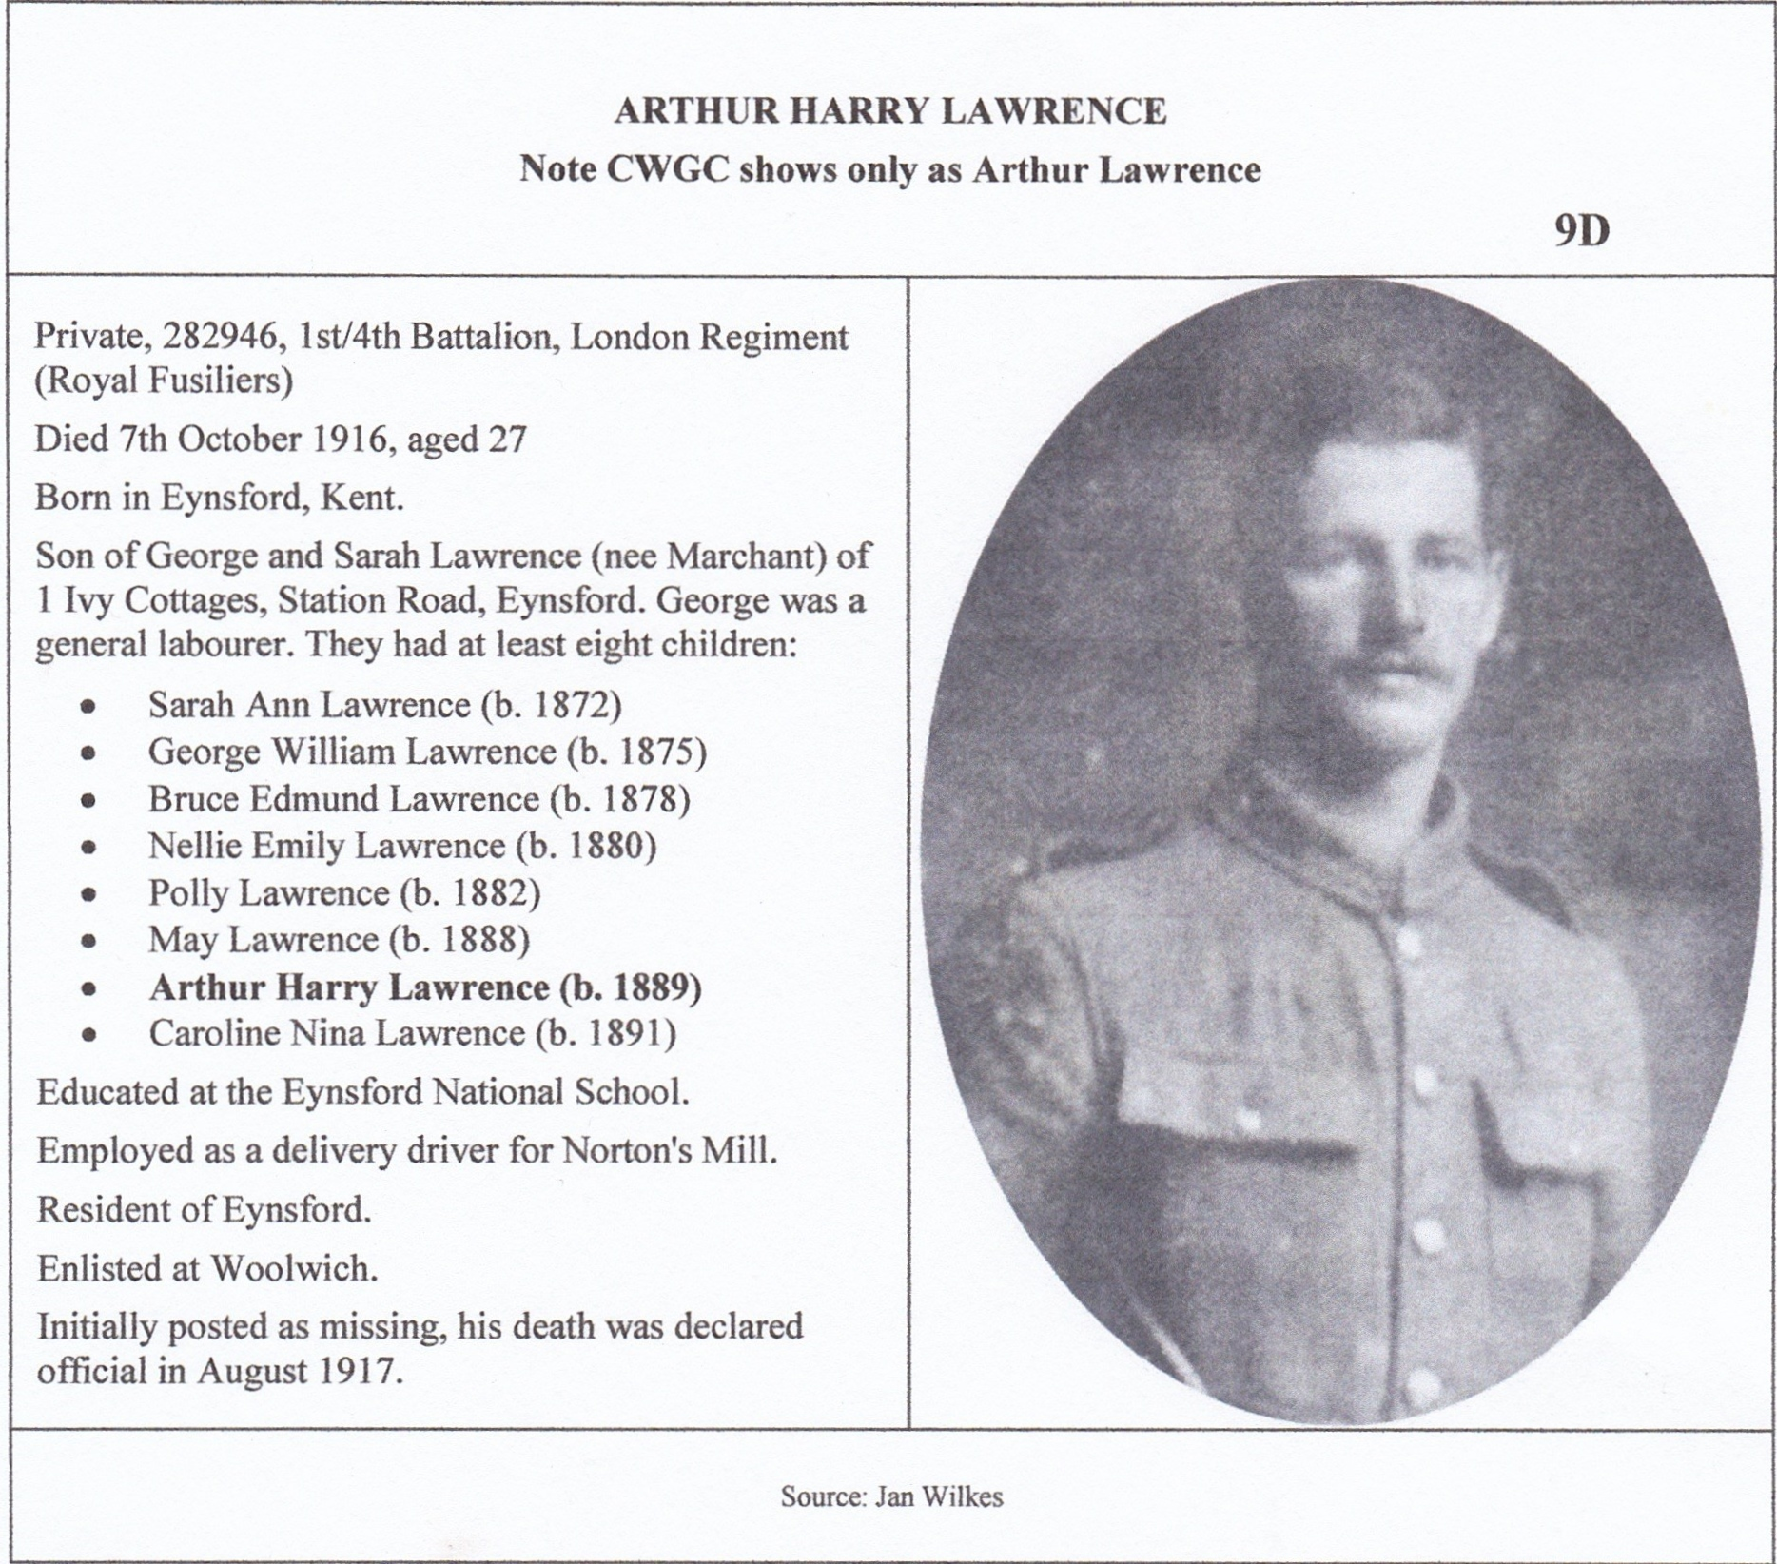
Arthur Lawrence is commemorated on the Thiepval Monument on the Somme. Both the Menin Gate and Thiepval Monument commemorate men who lost their lives but have no known graves. The Thiepval Database Project (Arthur Lawrence is now on this database) has been set up to gather as much information about these men, hoping eventually to have accessible the information about over 70,000 men. If anyone does know of a relative who is known to be on the Thiepval Monument get in touch with Pam and Ken Linge on pam_ken.linge@btinternet.com they will be very interested to hear from you.
Changing the subject to the Second World War, our next evening meeting is The Gentlemen at War presented by Roy Ingleton. He tells the story of the Police force during the war and how policing tasks and responsibilities underwent an almost complete change virtually overnight. The evening commences 7.30pm at Eynsford Village Hall.
Jan Wilkes – Editor - 865122

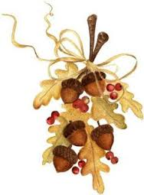

WHAT’S ON 2015
Horton Kirby & South Darenth Local History Society
2015
14th September The Edith Cavell Story – Paul Rason
9th November AGM followed by a talk and Cheese and wine

Meetings are held on Monday at the Village Hall, South Darenth from 8pm. If you require further information contact Barbara Cannell (01322 864253) (Remember your membership card) NOTE: The July meeting will be on a Thursday

Shoreham & District Historical Society

2015
16th October Women’s Land Army – Dr Ann Kneif
20th November Knockholt WW2 Secret – Paul Rason

Meetings held in the Village Hall Shoreham from 8pm. Members who wish to attend these meetings are advised to contact the Secretary Lynda Alleeson (01959 525312) to check that no changes have been made to their programmes (Remember your membership card)

Hextable Heritage Society

2015
10th September Dickens and Gads Hill – Anne Carter
8th October Edith Cavell – Paul Rason
12th November 5 Wents Hall and the Swanley & Hextable War Memorial Trust
December Christmas Party

Meetings are held at the Hextable Heritage Centre. Crawfords,Dawson Drive, College Road, Hextable 7.30pm start. If you require further information please contact Barbara Cannell (01322 864253) (Remember your membership card)
NOTE Details of the July visit will be announced later

